**Potential of Dimensionality Reduction and NeuralProphet for Predicting Global Temperature and the Effect of Stratospheric Aerosol Injection from Aerosol Optical Depth**

**By: Alayna Hall**

**Abstract**

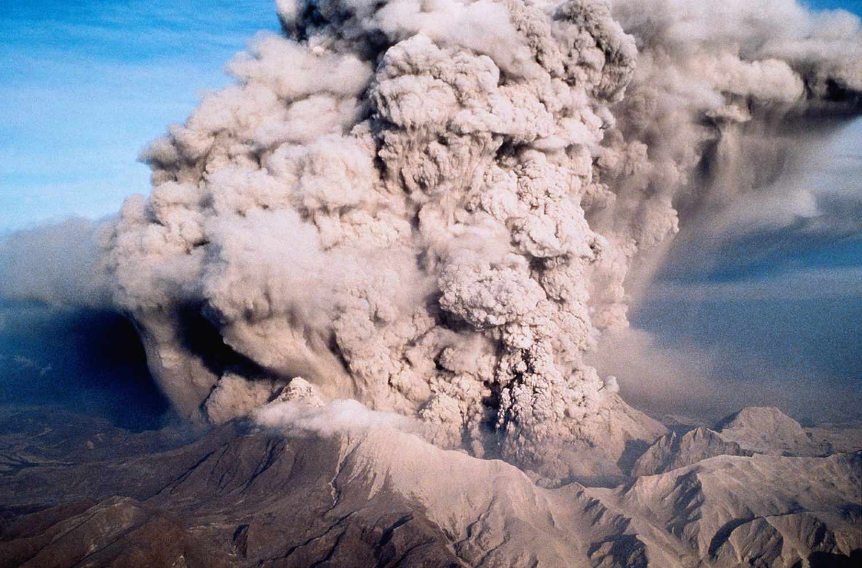This paper investigates the viability of Principal Component Analysis combined with NeuralProphet for predicting global stratospheric temperature based on aerosol optical depth in order to determine the effects of stratospheric aerosol injection as a climate intervention strategy. Stratospheric aerosol injection is the intentional release of aerosol particles into the atmosphere to reflect some solar radiation and provide a temporary cooling effect to Earth’s surface. Much of the research for stratospheric aerosol injection, including this paper, is focused on the effects of the 1991 eruption of Mount Pinatubo in the Philippines as a comparison for stratospheric aerosol injection. The data source is MERRA-2 reanalysis data from 1986 through 1998 for stratospheric temperature and aerosol optical depth. Because of the scope of spatial and temporal data, dimensionality reduction techniques provide an interesting solution to decrease necessary computation power for prediction. NeuralProphet was chosen for its combined effective predictions and interpretability in regard to seasonal time series. Four model variations were tested, incorporating different combinations of the number of principal components, aerosol optical depth as a lagged regressor, and calculating anomalies of the data (performing monthly climatology). Evaluation metrics and analysis of the residuals were used to assess the performance of the models. Effectiveness of the models, additional machine learning techniques, and key takeaways are discussed as further topics of research. This study contributes to current and ongoing discussions about how to predict the results of stratospheric aerosol injection, and it emphasizes the need for additional research to refine predictive models for the complexity of geoengineering endeavors.

Figure 2: Stratospheric Aerosol Injection20

Figure 1: Eruption of Mount Pinatubo16

**Introduction**

The purpose of this research is to explore the feasibility of stratospheric aerosol injection as a climate intervention strategy through predicting global temperature based on aerosol optical depth. Stratospheric aerosol injection is a geoengineering technique proposal where aerosol particles are purposefully released into the stratosphere by a various delivery method (including specialized aircraft and balloons) where the particles would then reflect and scatter a percentage of the incoming sunlight back into space – preventing some of the solar radiation from reaching the ground and warming it – resulting in a temporary cooling of the Earth’s surface.18

This idea draws heavily on the global climate cooling impact of volcanic eruptions, in particular the 1991 eruption of Mount Pinatubo in the Philippines. This eruption had a significant impact on the Earth’s climate and so it is often used as a basis for research when studying the effects of stratospheric aerosol injection. When volcanoes erupt, they release large amounts of sulfur dioxide, which reacts with water vapor in the stratosphere and creates sulfate aerosols. The sulfate aerosols that were released during the eruption of Mount Pinatubo spread across the globe in the stratosphere, and remained there for a long period of time where they reflected some of the sunlight and caused a temporary cooling effect.16

While the eruption of Mount Pinatubo was an uncontrolled release of these aerosol particles, stratospheric aerosol injection takes that concept and theoretically applies it in a controlled injection of aerosol particles. The comparison between the impact of Mount Pinatubo and intentional stratospheric aerosol injection is used to understand the potential risks and challenges posed by stratospheric aerosol injection. These concerns include disrupting precipitation patterns, detrimental impacts on ecosystems, international relations and national security. Additionally, stratospheric aerosol injection is a temporary solution as it does not address the root cause of accumulation of greenhouse gases in the atmosphere.20

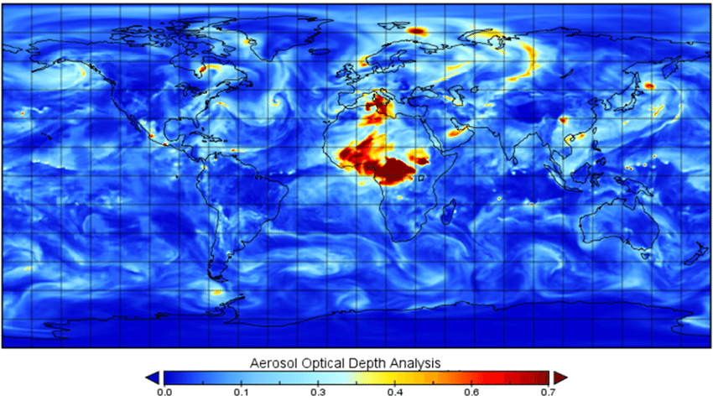Owing to these complex questions, stratospheric aerosol injection is currently the topic of much ongoing research from both scientists and policy makers to understand its effects. This research utilized the MERRA-2 reanalysis data for stratospheric temperature (interchangeable with “temperature” for the purposes of this paper – all other temperatures will be specified) and aerosol optical depth (AOD) from January 1st, 1986 through December 10th, 1998. The Modern-Era Retrospective Analysis for Research and Applications, version 2 (MERRA-2), is a dataset of global atmospheric reanalysis from 1980 onward, and a product of NASA’s Global Modeling and Assimilation Office (GMAO). Reanalysis is the integration of multiple observational data sources (satellite measurements, surface observations, etc.) into a single numerical model of the Earth’s atmosphere.13 This creates a consistently continuous record of historical climate conditions and weather with a high spatial and temporal resolution. A machine learning environment in addition to dimensionality reduction techniques is a possible way to attempt the effective prediction of stratospheric temperature based on the aerosol optical depth in order to interpret the possible global effects of stratospheric aerosol injection in addition to providing framework to detect deviance from expected temperature values.

Figure 3: Example Daily Mean MERRA-2 Total AOD Global Dataset10

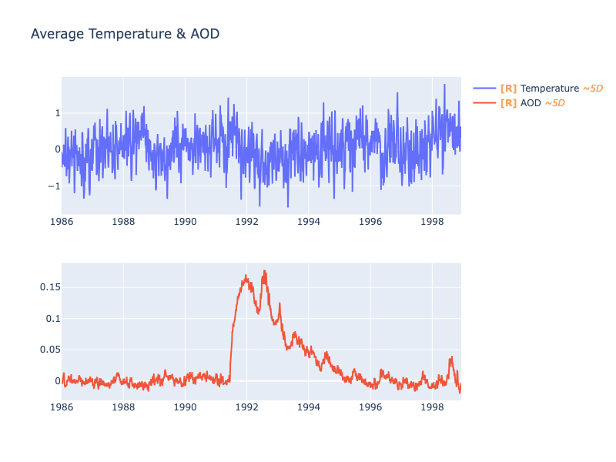**Data Processing**

This research employed a dual-coding approach, utilizing Python for machine learning tasks and R for certain aspects of data processing and organization. Stratospheric temperature was the response variable, where the previous day’s temperatures and aerosol optical depth were predictor variables.

The MERRA-2 reanalysis data is collected from 1152 locations (24 latitude and 48 longitude pairs) and spans approximately 12 years. To decrease the computational power needed for predicting temperatures at each of these locations, the dimensionality of the spatial aspect of the data needs to be reduced. Utilizing Principal Component Analysis (PCA), the data will be processed to set all locations as features before applying PCA.2

Figure 4

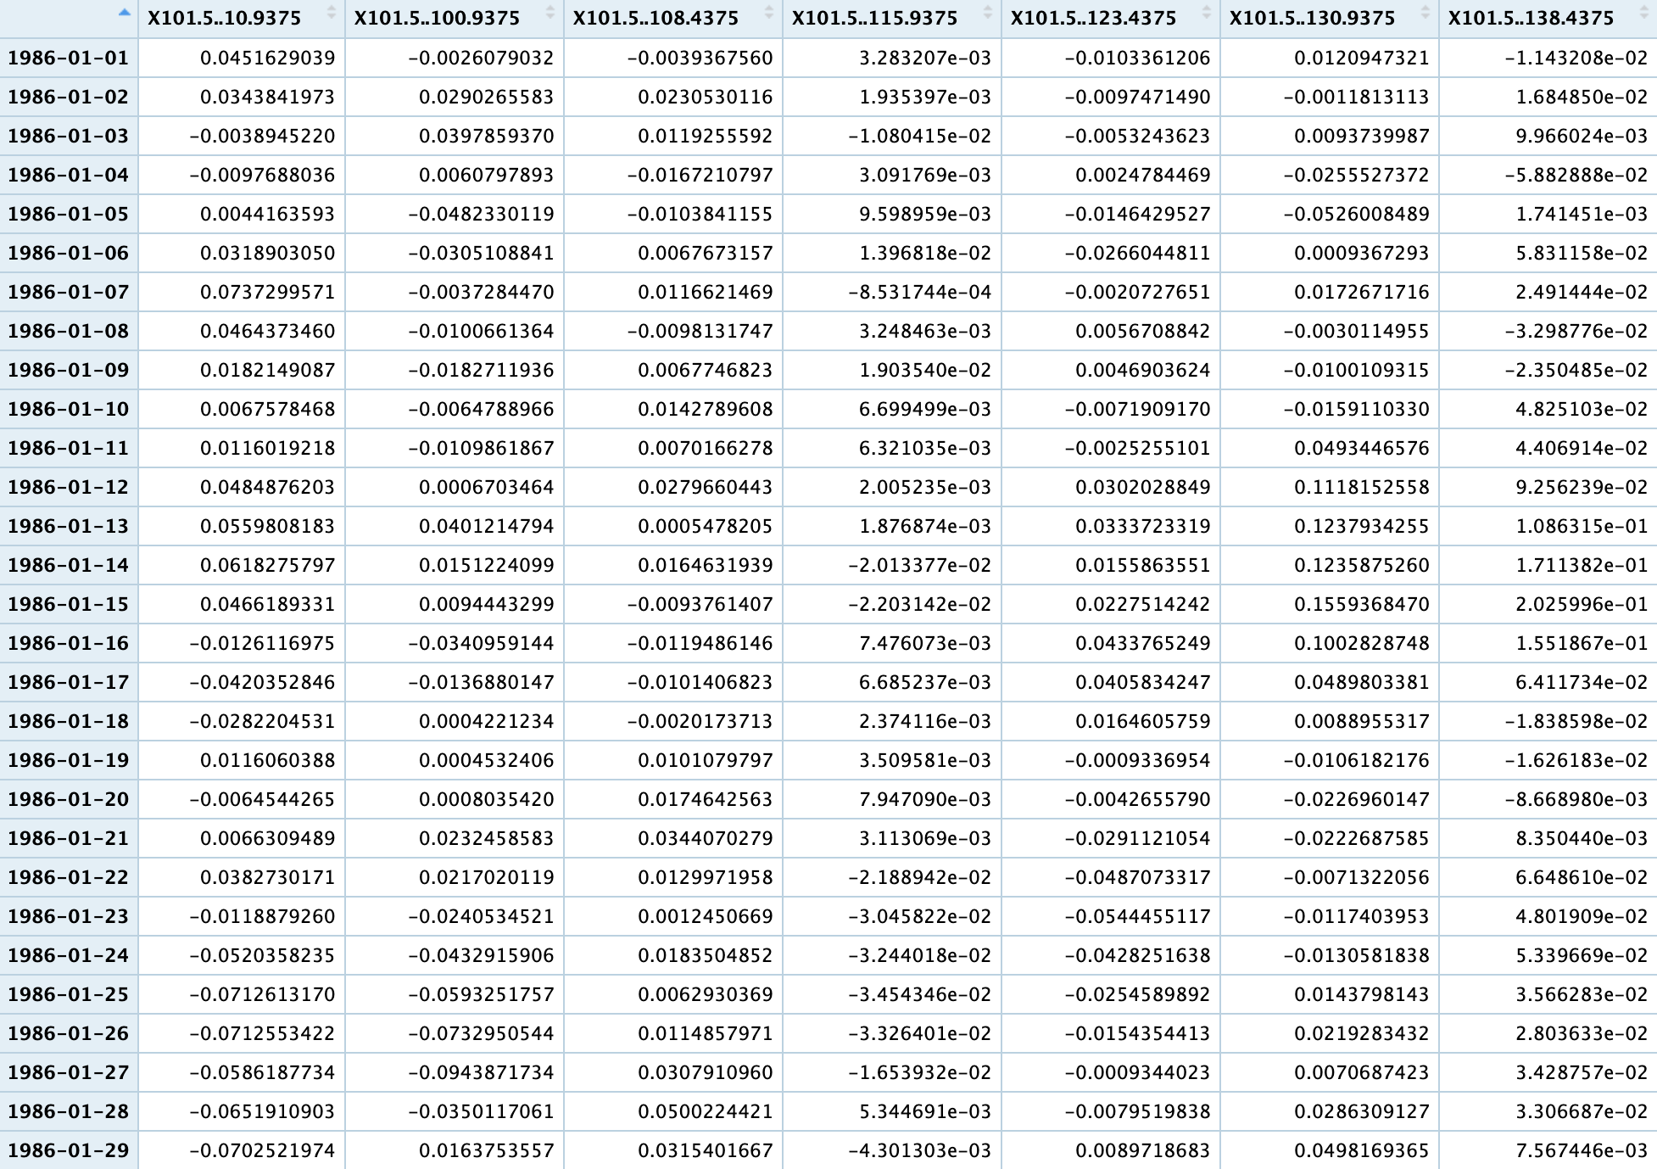Initially, the data is imported into Python to be cleaned and ensure the time series for temperature and AOD are the same length. Then, the anomalies were calculated for three of the four model variations by subtracting the monthly mean of each location for the training date range (January 1st, 1986 through December 31st, 1990) from the total time frame of the data (this process will be referred to as “performing monthly climatology” or “climatology” of the data). In order to ensure the ability to recompose latitude and longitude while maintain the differences between negative and positive locations, those measurements were converted into the positive range by adding 90 and 180 degrees to latitude and longitude measurements respectively. For PCA to be applied, the latitude and longitude needed to be merged into single location variables, so they were combined with a separator to make it simple to convert the location back to separate latitude and longitude after prediction.

The data was then imported to R to split each location into a separate column (image 1), so that PCA could be applied. In Python, the data was scaled, and then the PCA function (which utilizes Singular Value Decomposition (SVD)) was fit on the temperature data and applied to both temperature and AOD (for the model variations utilizing lagged regressors). This method ensured that the same information and “features” would be included in the principal components (PCs) for both temperature and AOD.5

Figure 5: Data Processing in R – Splitting into Columns by Location

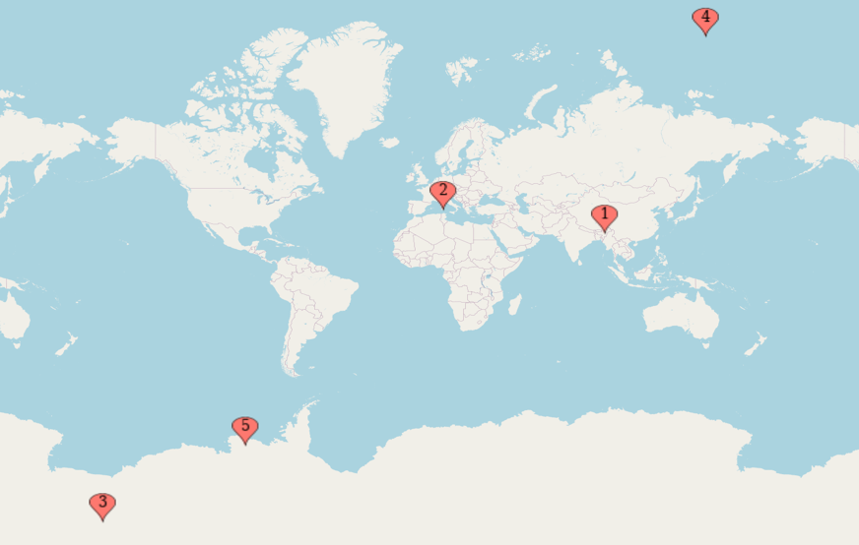The PCA determined the most important features which are mapped out in image 2 below. For both the PCA performed on climatology data and non-climatology data, locations near the poles were determined to be the locations that explain more variance than the other locations, which is interesting when the results of the recomposed data and their residuals by location are viewed. After performing PCA, the data was split into individual dataframes for each PC, temperature is renamed to “y”, and AOD is renamed to “x”. Then, each dataframe is split into the training and testing sets for use in the actual models, where each PC would be used in an individual model.

Figure 7: Most Important Features – Non-Climatology Data4

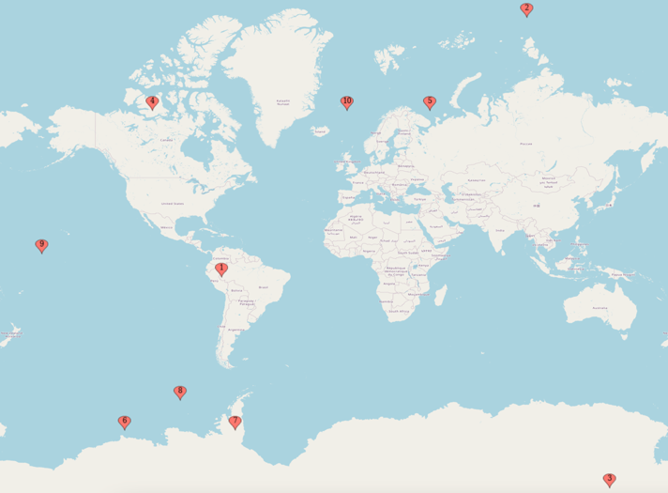

Figure 6: Most Important Features – 10 PCs4

**NeuralProphet**

Because this is a time series based on temperature, it is correctly assumed that there is autocorrelation so a forecasting model that can reconcile that correlation is necessary. NeuralProphet is a time series forecasting library built on top of the PyTorch deep learning framework, inspired by Facebook Prophet and AR-Net. It is designed to provide powerful and effective predictive capabilities while maintaining interpretability and it is best for long running time series of two years or more. It utilizes an easy-to-use neural network architecture with fully connected layers making it well-suited for representing intricate temporal dependencies.

Figure 814

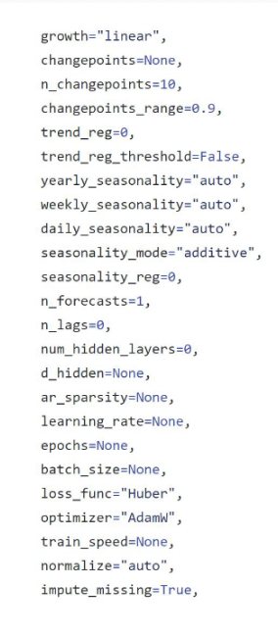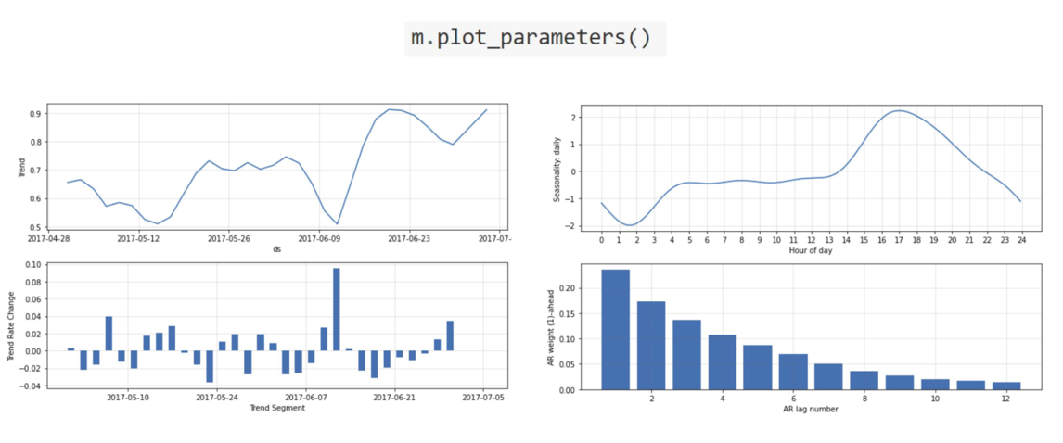In essence, NeuralProphet was designed to balance being user-friendly with exceptional performance in addition to high levels of customization depending on the experience level of the user. During training, the model learns to map input features (this includes trend, seasonality, lagged regressors, time-related features, etc.) to the target variable. Its primary strength is in the accommodation of seasonal trends through automatic detection using Fourier terms and piecewise linear trends. Because of its ability to understand complex patterns, climate is often cited as an ideal application for the use of NeuralProphet, and the provision of interpretable results allow for the understanding of the contributions of things like seasonality and trend in the overall climate forecast.

Figure 9: Model Customization Options14

Figure 10: NeuralProphet Parameters for Interpretation14

**Model Variations**

Version 1: 5 PCs, AOD, Climatology

Version 2: 10 PCs, AOD, Climatology

Version 3: 5 PCs, Climatology

Version 4: 5 PCs, AOD

In order to determine the viability of PCA and NeuralProphet for predicting stratospheric temperature and the importance of different predictor variables, four variations of models were created – in essence performing manual feature selection. The first version (the baseline) included five principal components (chosen for manageability and proof of concept), aerosol optical depth (AOD) as a lagged regressor, with monthly climatology performed on the data. The additional three variations differed from the first version by one variable each: the second version increased principal components from five to ten to determine the feasibility of PCA, the third version removed AOD as a lagged regressor to assess the importance of AOD in predicting temperature, and the fourth version used data where monthly climatology was not performed to evaluate the capabilities of NeuralProphet.

For all versions, the basic model was customized to have the learning rate lowered to 0.01 in order to increase convergence and stability. For the first three versions, the model was further customized with growth = “off”, seasonality_mode = “off”, seasonality = “off, n_lags = “4”, and, for versions one and two, lagged_regressor = x (AOD). The fourth version was slightly different with increased lags and seasonality modes; growth = “linear”, seasonality_mode = “multiplicative”, yearly_seasonality = “TRUE”, n_lags = “20”, and lagged_regressor = x (AOD).

**Explained Variance**

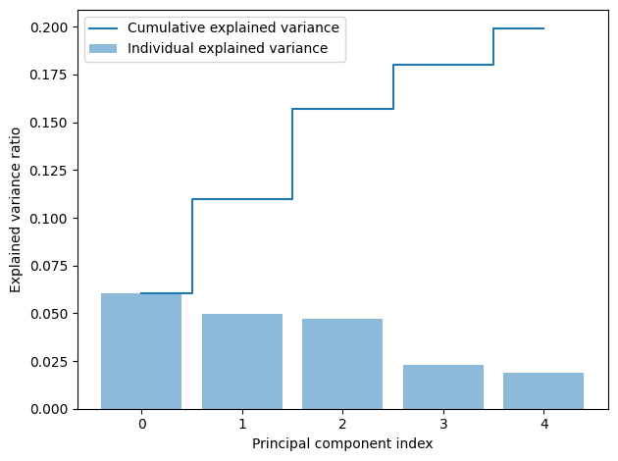Version 1: 19.9%

Version 3: 19.9%

Figure 11: PCA Explained Variance Graphs

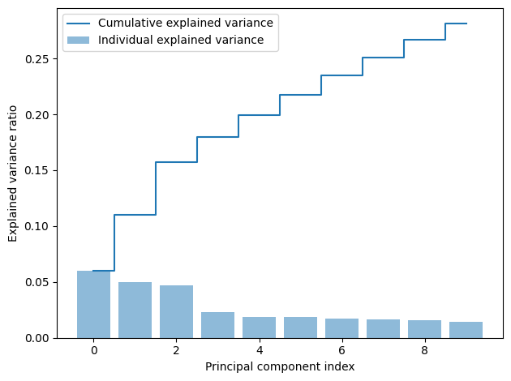Version 2: 28.1%

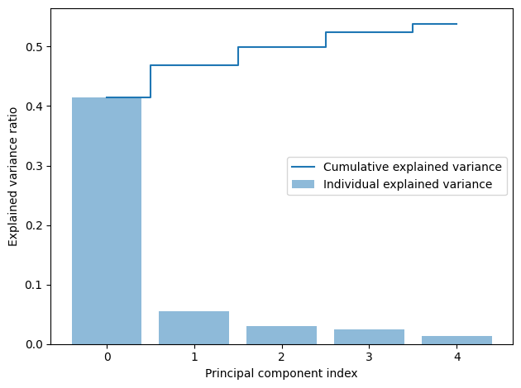Version 4: 53.8%

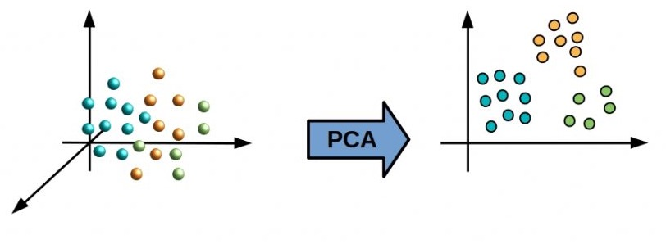The explained variance from all the principal components combined is an interesting factor when we consider the predictions and recomposed data. Version 1 and Version 3 are fit the exact same way, with the same number of principal components, so it makes sense that they have almost identical explained variance, but under twenty percent is quite a low amount of variance to be explained and could result in incorrect recomposition into the temperature dimension. Version 2 has the second highest explained variance, and it was expected that it would be higher than Version 1 and Version 3 because of the increased number of principal components, but it is still not capturing the amount of variance normally necessary for accurate recomposition. Version 4 has two to three times the amount of captured variance of the other versions, which is initially surprising until realizing that much of the variance of was removed when seasonality was removed.

Figure 12: Visualization of PCA15

**Predictions**

**Version 1:**

Visually, the predictions for each principal component appear to be predicting fairly accurately, with only a small number of outliers (or missed “y” values).

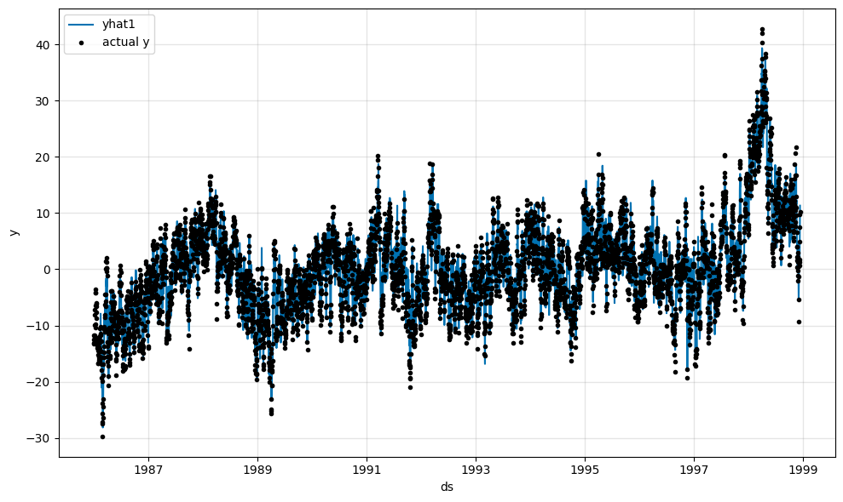 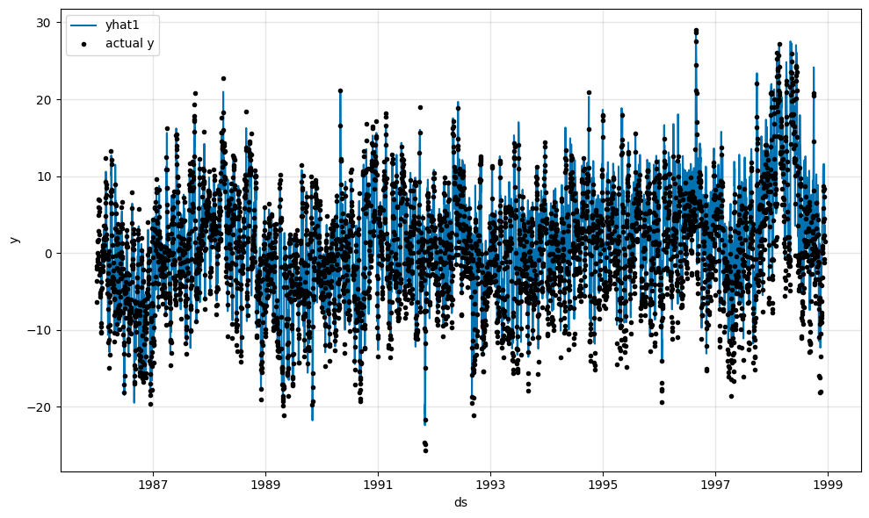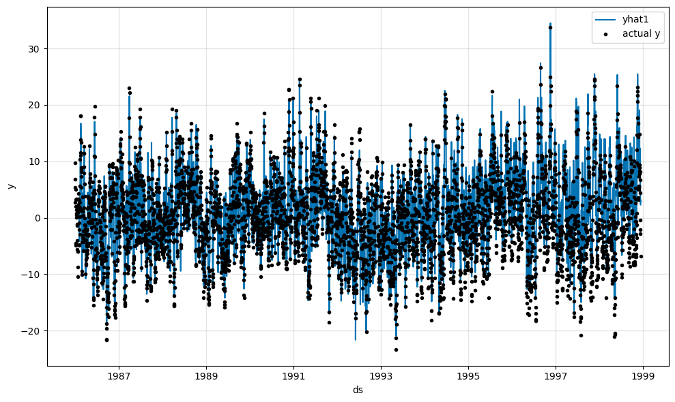 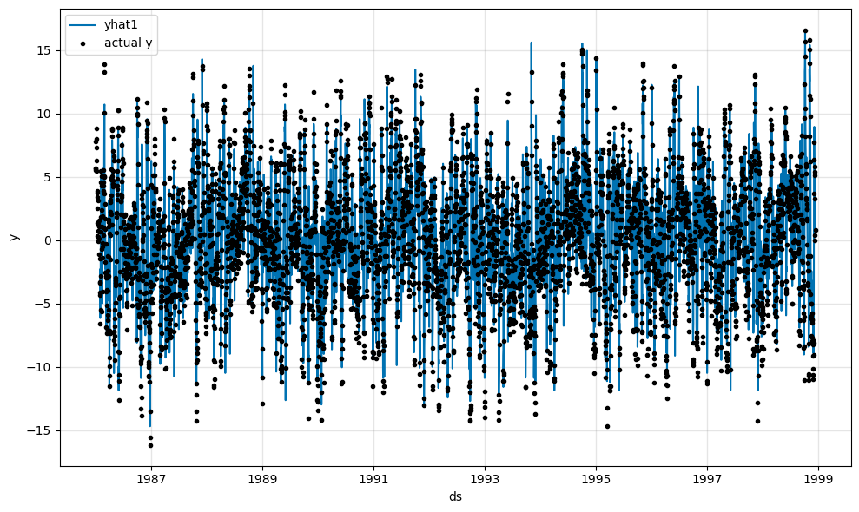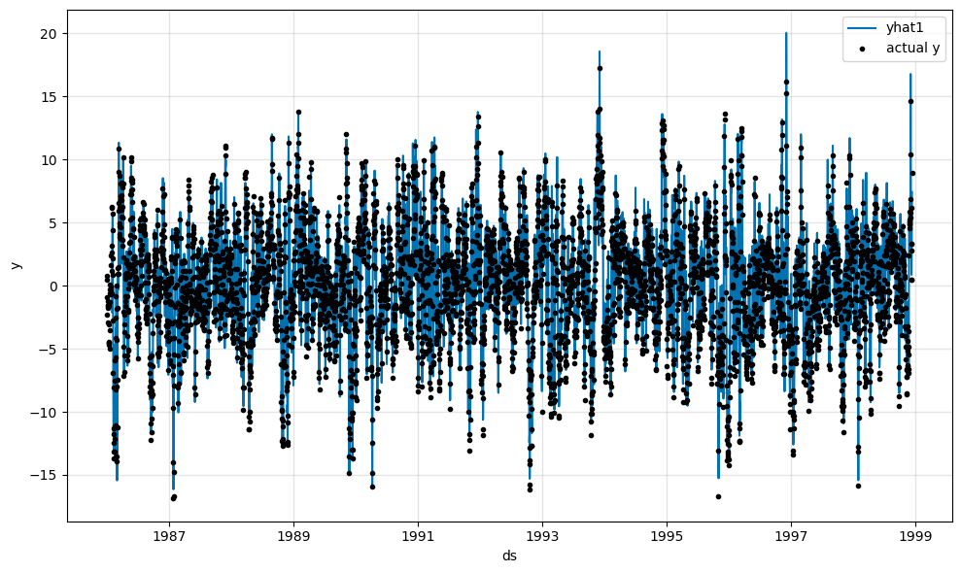

Figure 13: Version 1 Predictions (PCs 1-5 from Left to Right)

**Version 2:**

The predictions appear to have increased in accuracy with the additional five principal components, although there are still some outlying “y” values.

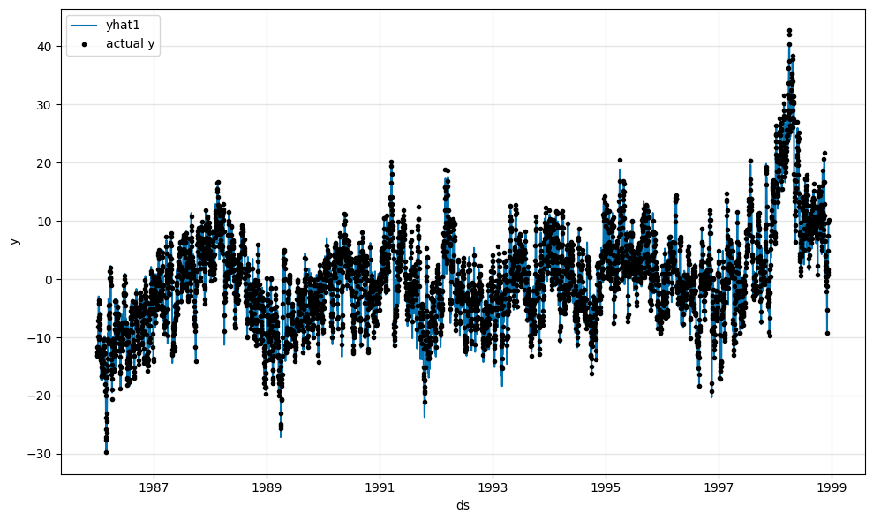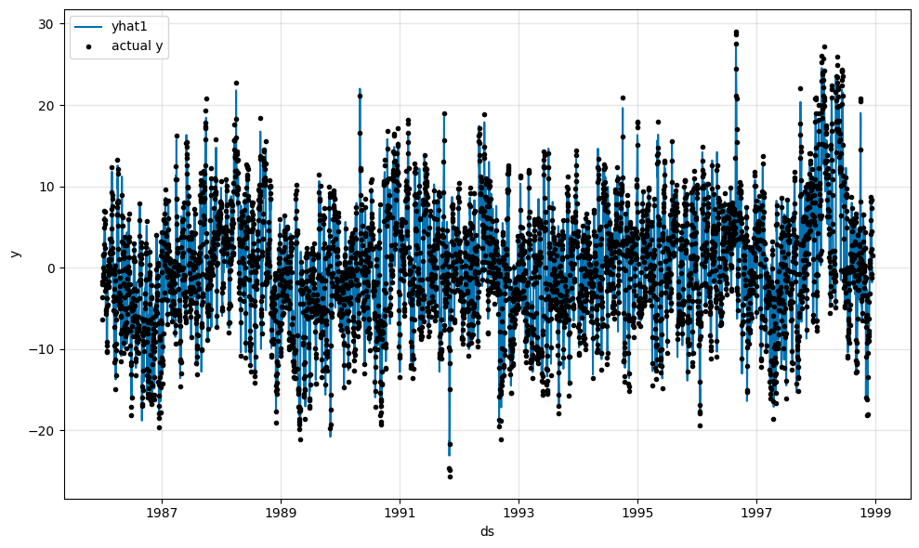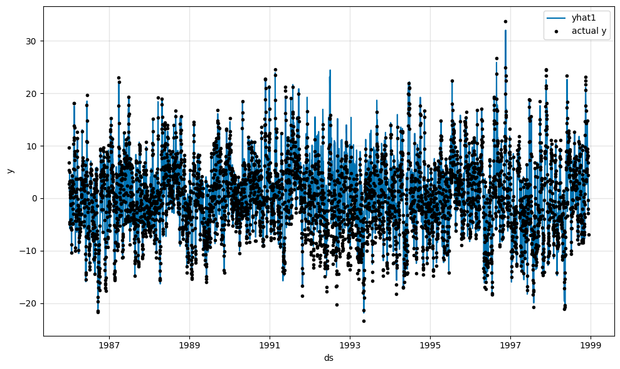 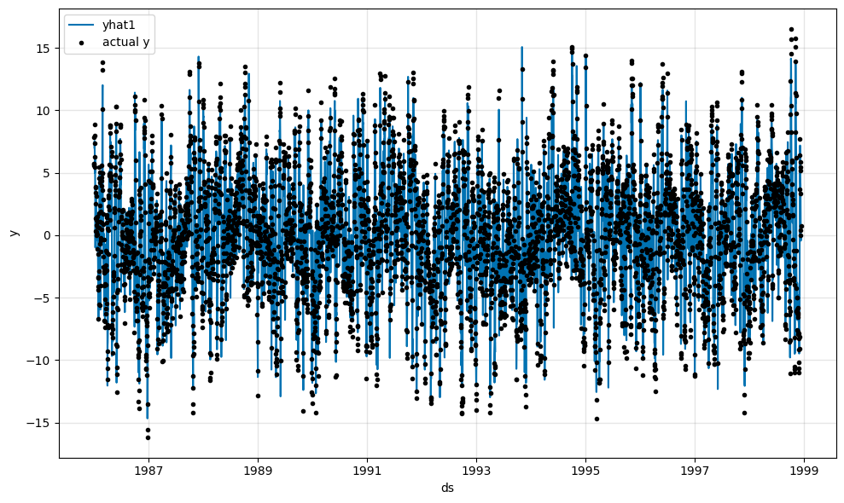

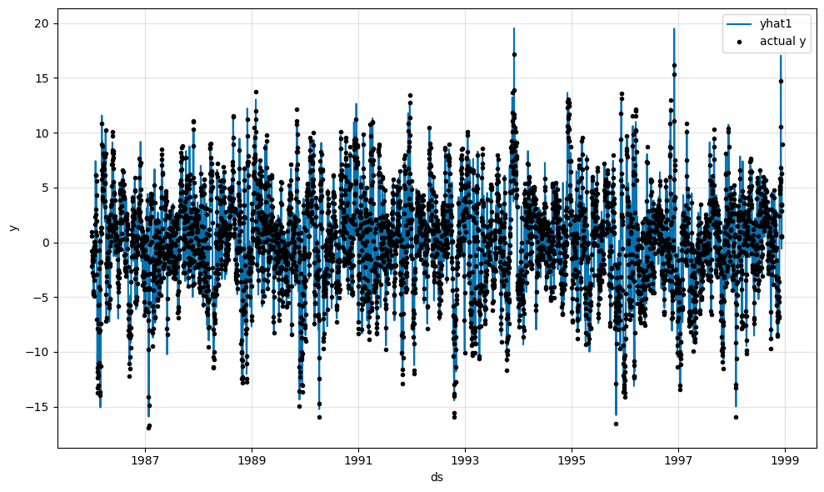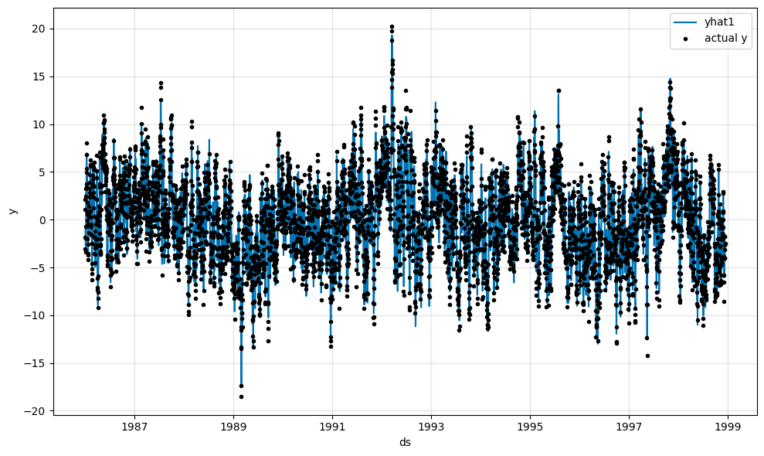

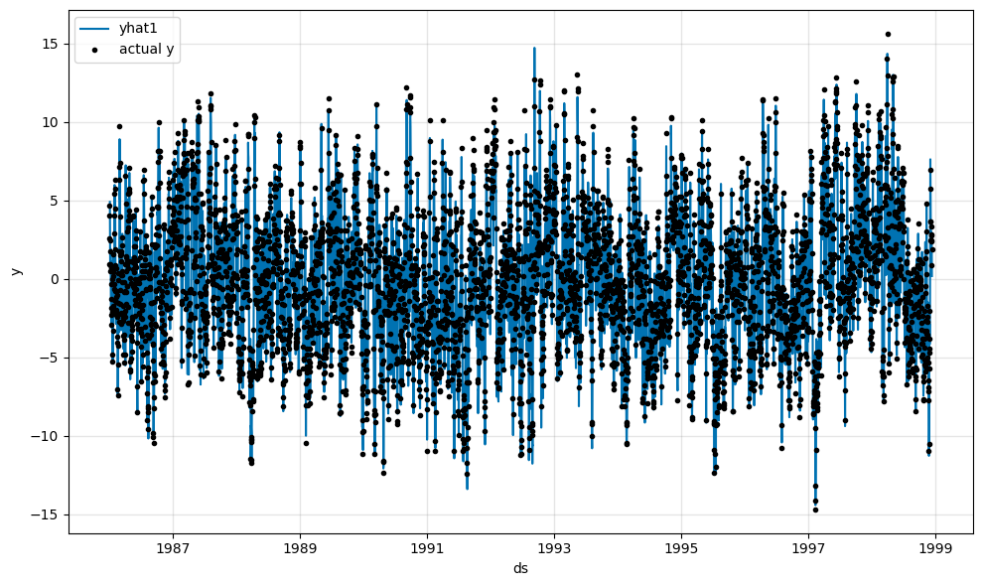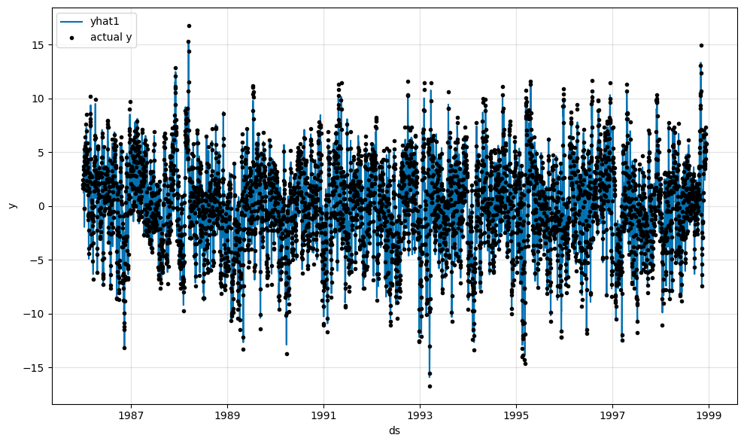

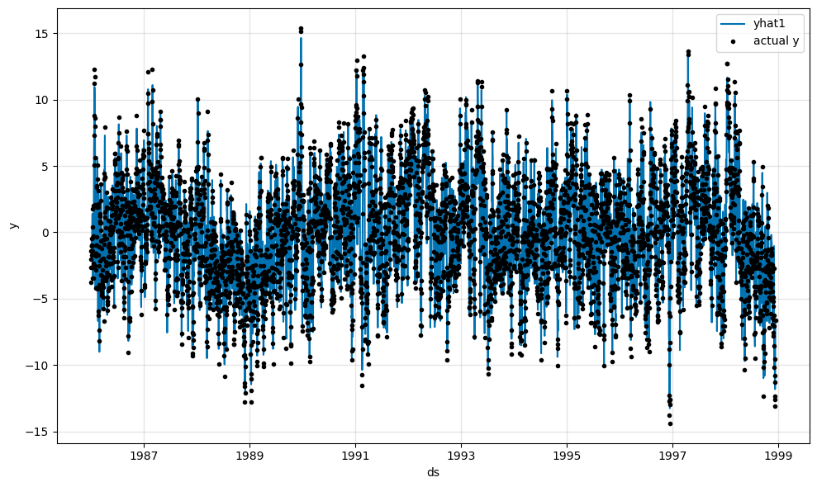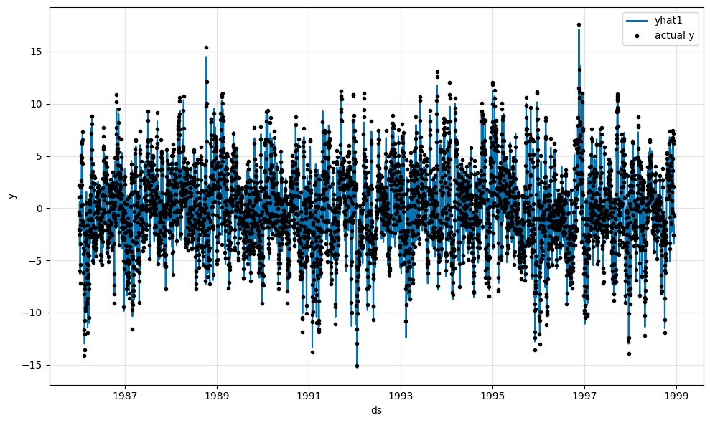

Figure 14: Version 2 Predictions (PCs 1-10 from Left to Right)

**Version 3:**

When assessing the predictions visually, it does not appear that AOD dramatically affects the predictions.

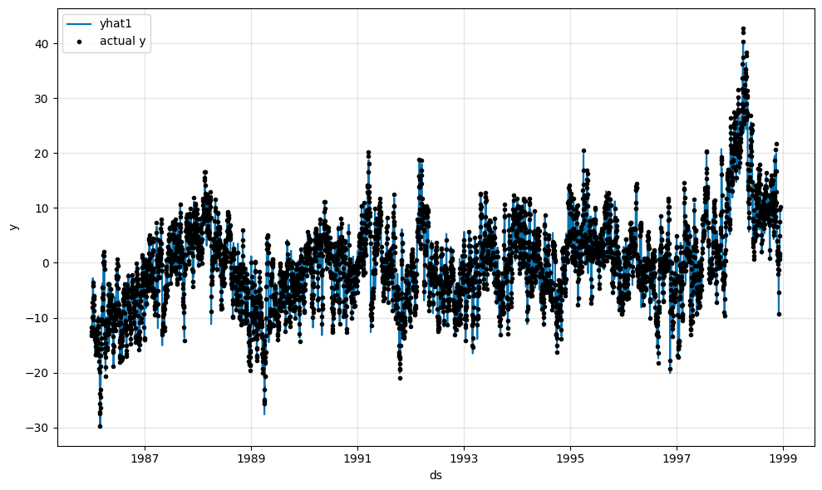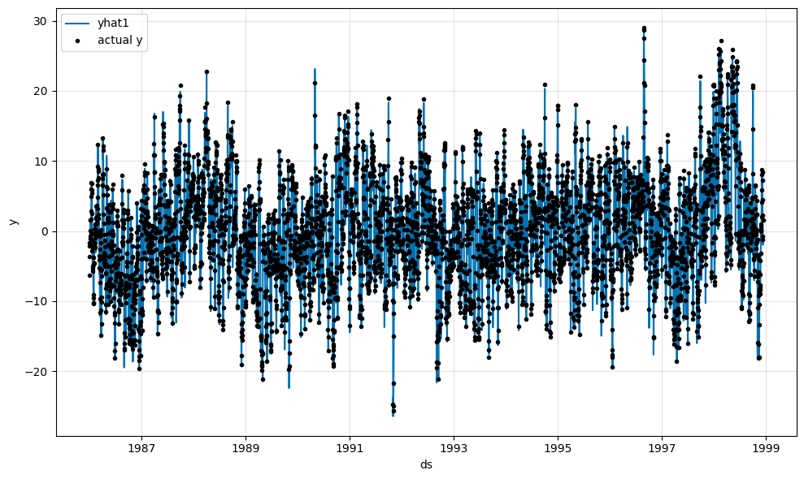

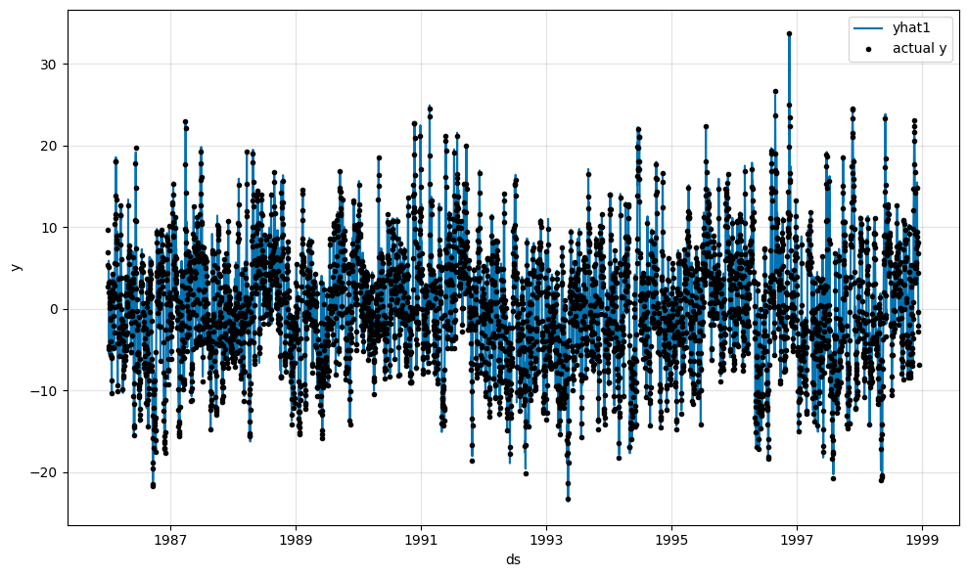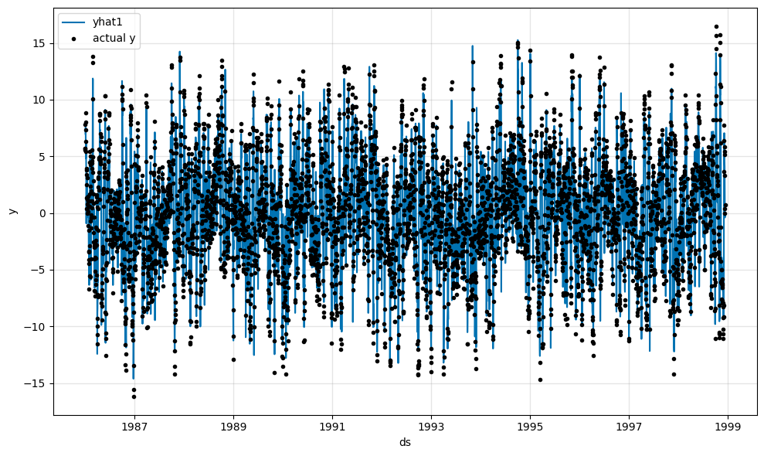

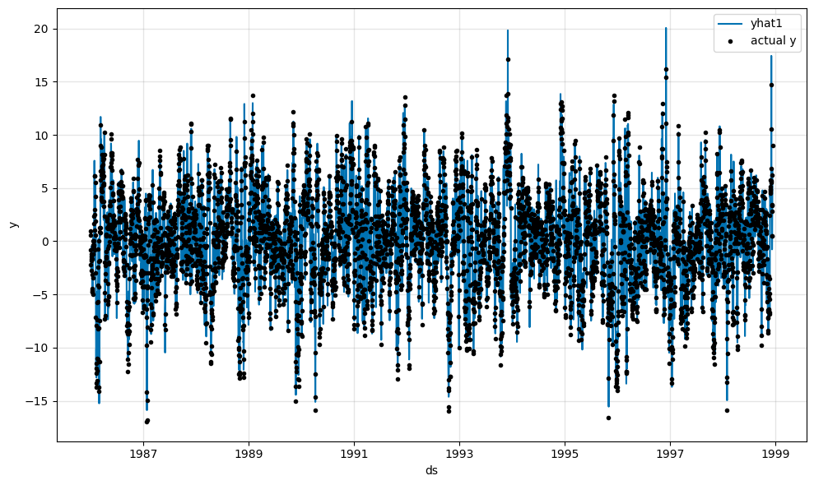

Figure 15: Version 3 Predictions (PCs 1-5 from Left to Right)

**Version 4:**

This version is the most visually different which is explained by the seasonality being accommodated through model parameters, and not by removing the monthly mean. In all likelihood, the PCA could have clustered the locations based on latitude bands.

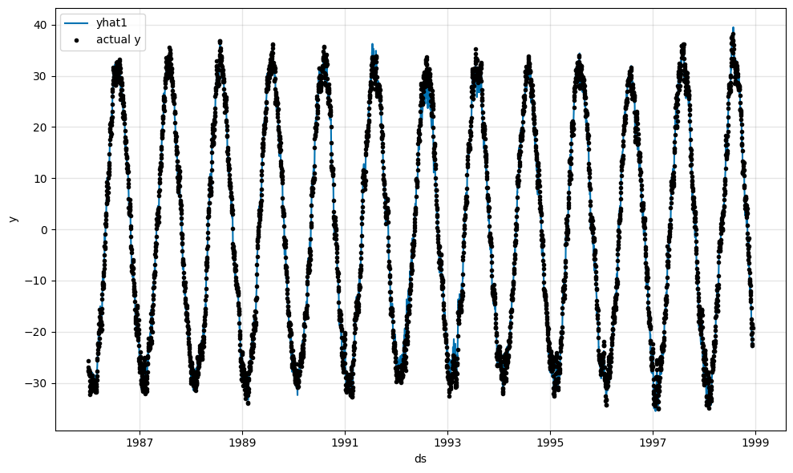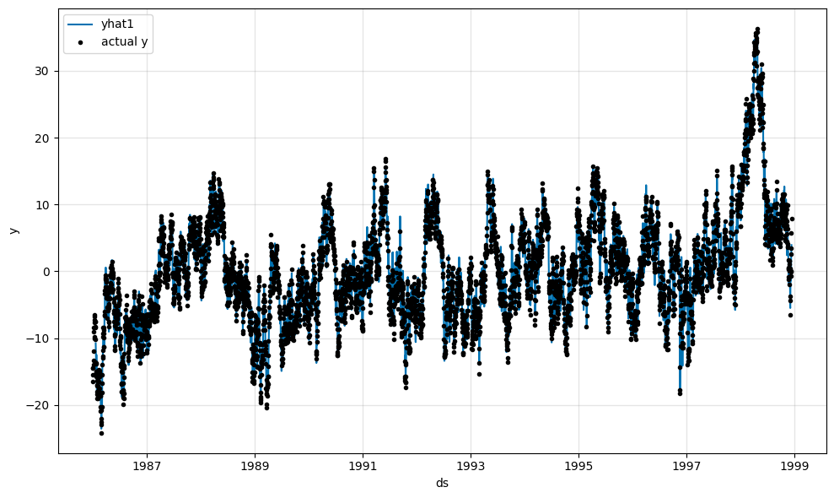

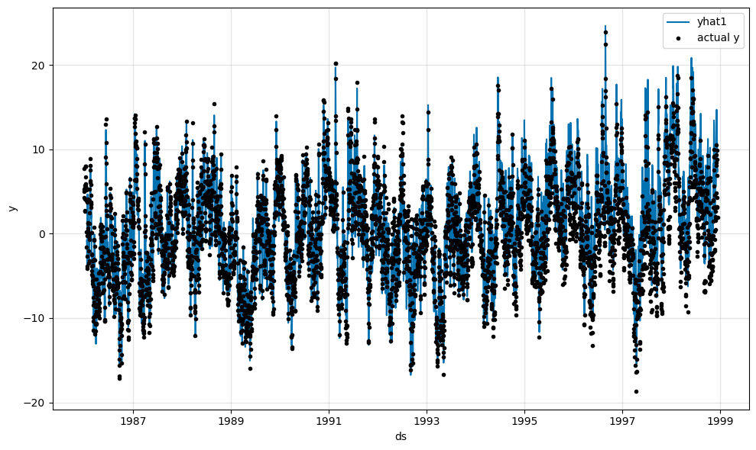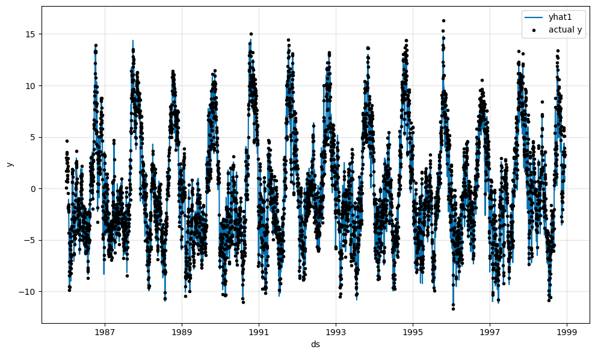

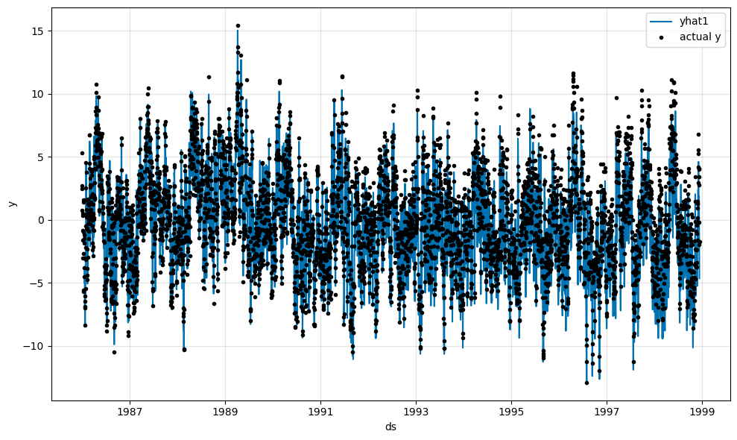

Figure 16: Version 4 Predictions (PCs 1-5 from Left to Right)

The seasonality mode was set to multiplicative instead of additive to encapsulate the increased fluctuation of the seasonality over time which can be seen in the yearly seasonality graph (left) and the overall trend for the temperature in each principal component can be seen as well (right).

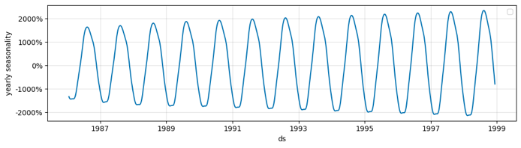 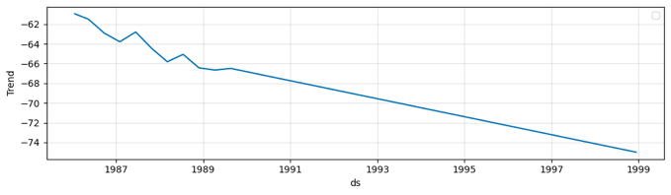

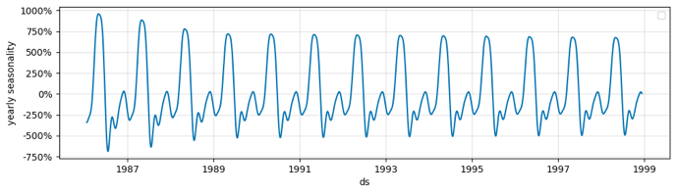 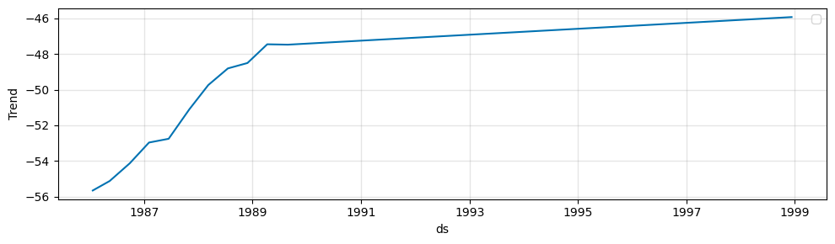

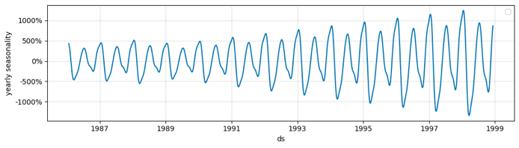 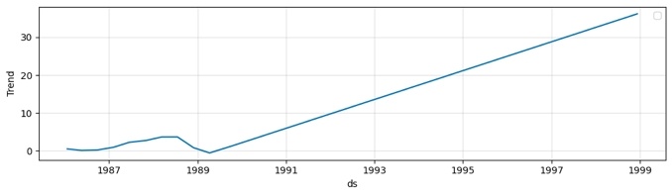

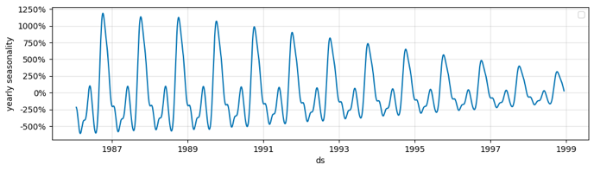 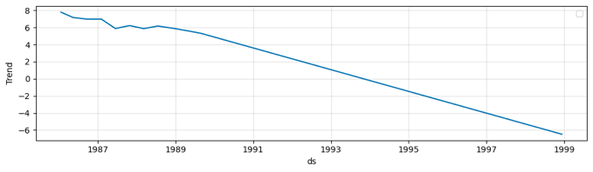

Figure 17: Version 4 Seasonality & Trend (PCs 1-5 from Top to Bottom)

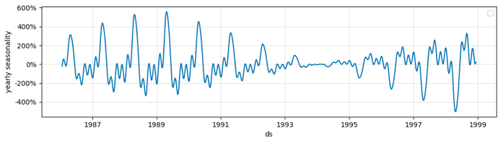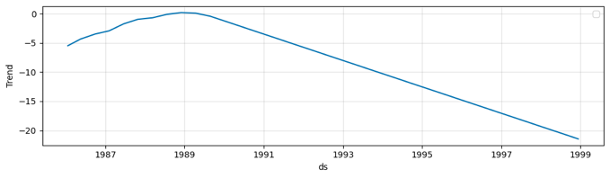

**Model Evaluation**

**Performance Metrics – Loss, MAE, RMSE**

Loss, Mean Absolute Error (MAE), and Root Mean Squared Error (RMSE) of the testing set are the first performance evaluation metrics to be examined, with the lowest values in bold.

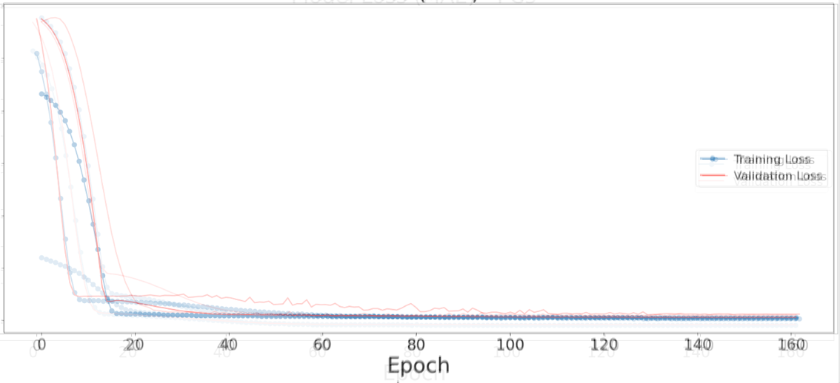Version 1:

Loss_Test:

0.003893

MAE_Val:

1.894211

RMSE_Val:

2.643849

Figure 18: Version 1 Overlapping MAE/Loss Graphs

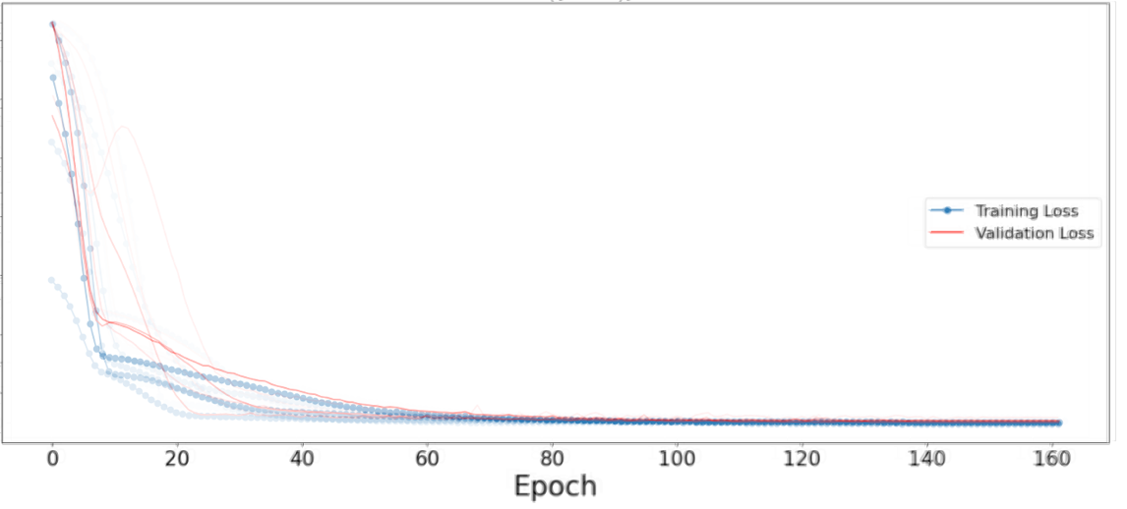Version 2:

Loss_Test:

0.003755

MAE_Val:

1.784527

RMSE_Val:

2.353894

Figure 19: Version 2 Overlapping MAE/Loss Graphs

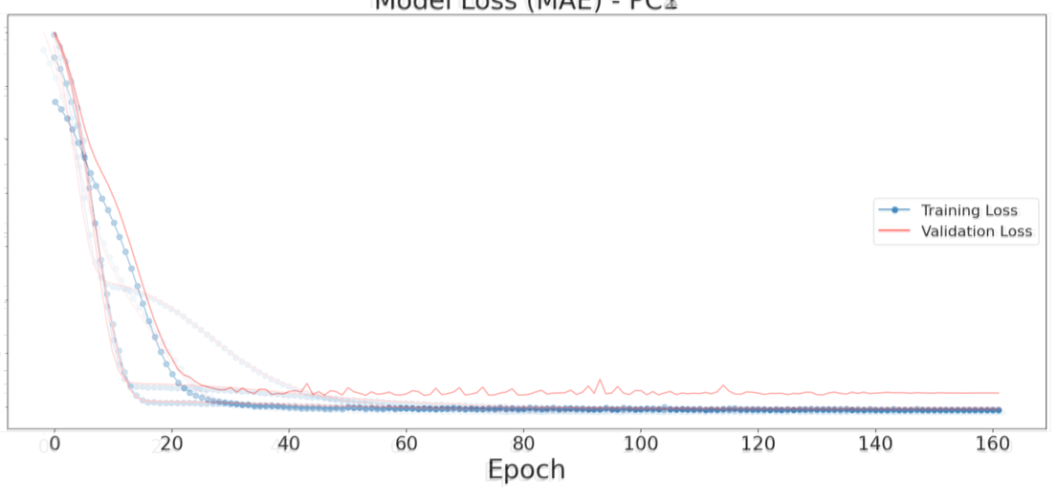Version 3:

Loss_Test:

0.003781

MAE_Val:

1.830704

RMSE_Val:

2.573007

Figure 20: Version 3 Overlapping MAE/Loss Graphs

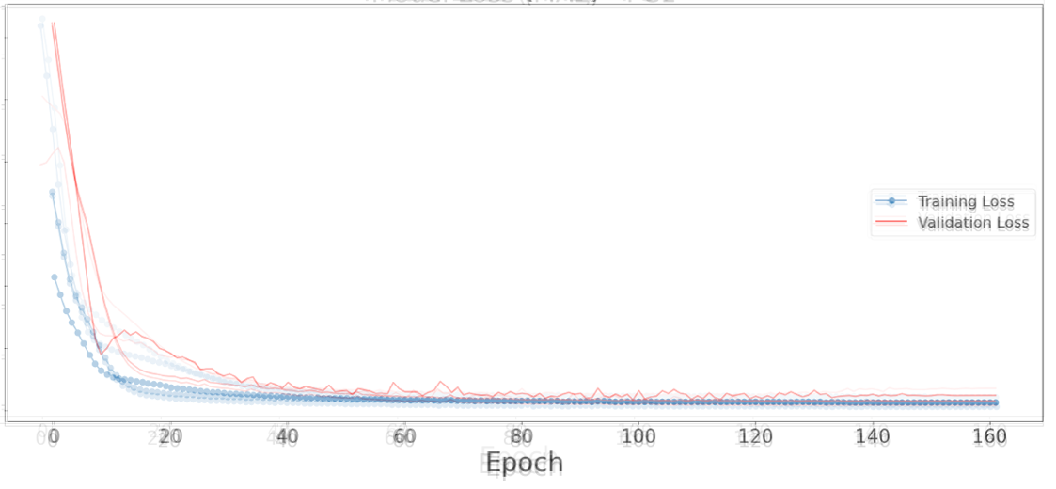Version 4:

Loss_Test:

**0.003307**

MAE_Val:

**1.614566**

RMSE_Val:

**1.993623**

Figure 21: Version 1 Overlapping MAE/Loss Graphs

**Principal Component Residuals**

When assessing the residuals (these are the residuals of the principal components, not of the actual difference between predicted values and real temperature), a graph of the largest principal component residuals in addition to the average range of residuals for each version are shown for comparison:

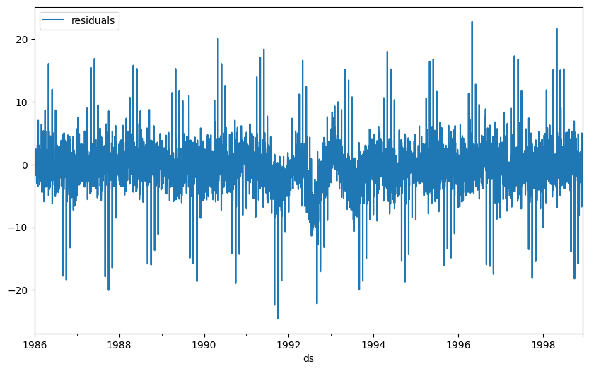Version 1:

Average Residual Range: 31

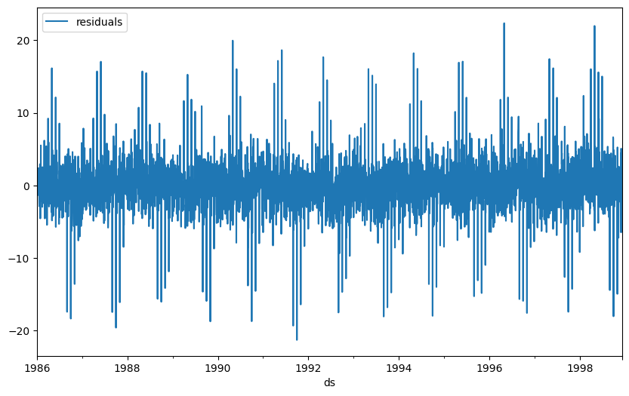

Figure 22: Version 1 – Graph of PC3 Residuals

Version 2:

Average Residual Range: 21

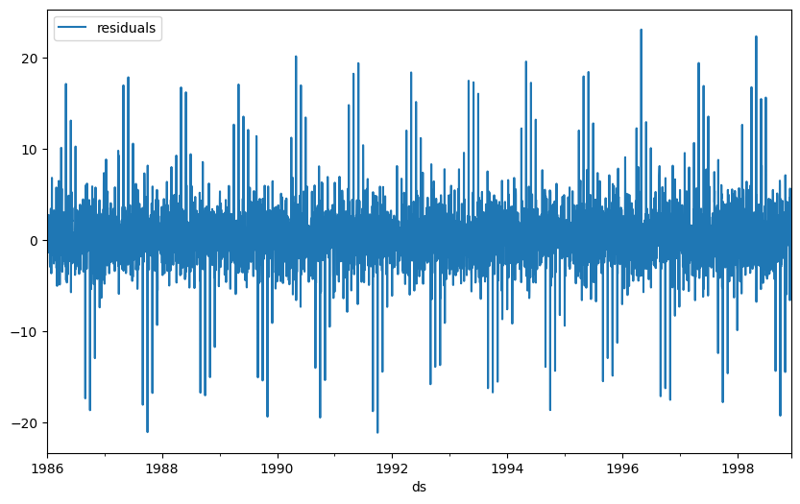

Figure 23: Version 2 – Graph of PC9 Residuals

Version 3:

Average Residual Range: 46

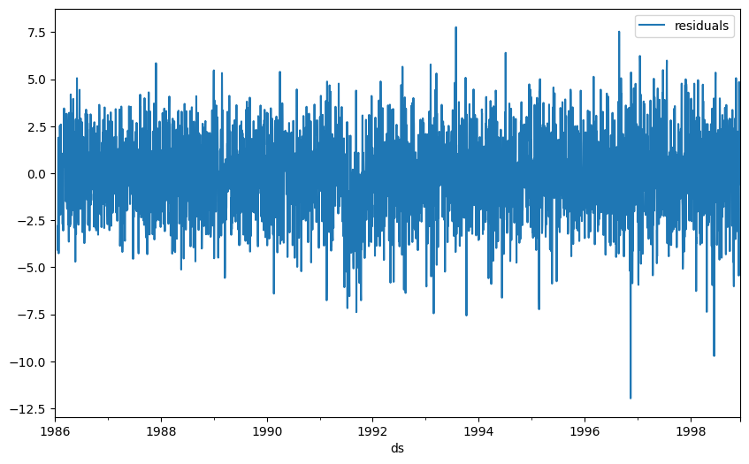

Figure 24: Version 3 – Graph of PC4 Residuals

Version 4:

Average Residual Range: 15

Figure 25: Version 4 – Graph of PC4 Residuals

**Recomposing the Data Back Into the Original Dimensions**

To analyze the actual differences between the predicted and dimension-reduced data, the predicted data for each principal componenet was merged into a single dataframe and then doing an inverse transformation by multiplying the principal components by the transpose of the original loading matrix used in the PCA.12 After that, the scaling of the data was reversed. Once this process was complete, the data was exported to R and reorganized by pivoting all the columns to below each other making it the same format as the original dataframe. Once the modified and formatted data was imported back into Python, the locations were split into separate latitude and longitude measurements, and converted to their actual values by subtracting 90 from the latitude, and 180 from the longitude measurements. For the first three versions, the climatology was reversed by adding the monthly mean by location back to the temperature. Analogous processes were performed for AOD and non-predicted temperature to assess the accuracy of the PCA. R was utilized to make comparisons to the original data, comparing both the mean difference over time (graphed as mean difference squared for better analysis) and the mean difference by location (graphed as mean difference scaled [0,10] for model comparison). What’s more, the minimum and maximum mean differences for each version, the size of that range, and the overall mean difference for the model were found as a numerical comparison metric.

**Recomposed & Scaled Temperature Difference (Predicted Values)**

The maximum range size of mean difference over time is approximately three degrees, which is fairly successful for only having five to ten principal components. For the predicted and recomposed data by time, it is interesting to see that the difference or residuals dramatically increase in variance during the time frame of the testing set. For the fourth version (with the best total mean difference) it has a fairly consistent range of residuals, so it appears that it is predicting better than the other versions with climatology.

Figure 26

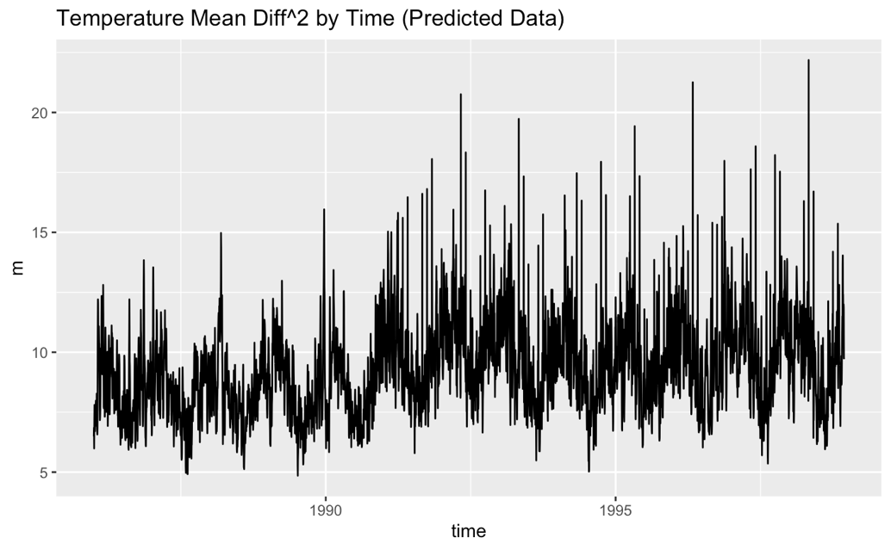Version 1:

Min/Max:

[-1.758294, 1.223444]

Range Size:

2.981738

Total Mean:

-0.03963688

Figure 27

Version 2:

Min/Max:

[-1.745101, 1.3143888]

Range Size:

3.059489

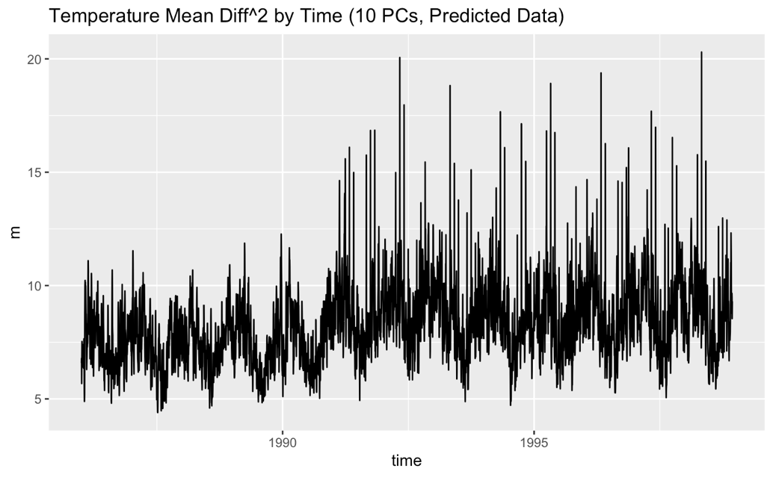

Total Mean:

-0.02613863

Figure 28

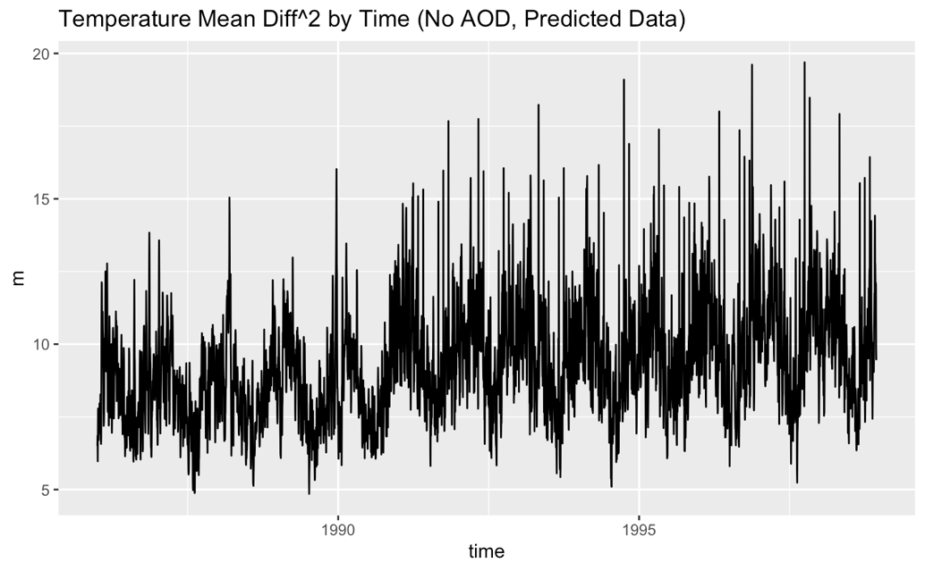

Version 3:

Min/Max:

[-1.541459, 1.340342]

Range Size:

2.881801

Total Mean:

0.03487284

Figure 29

Version 4:

Min/Max:

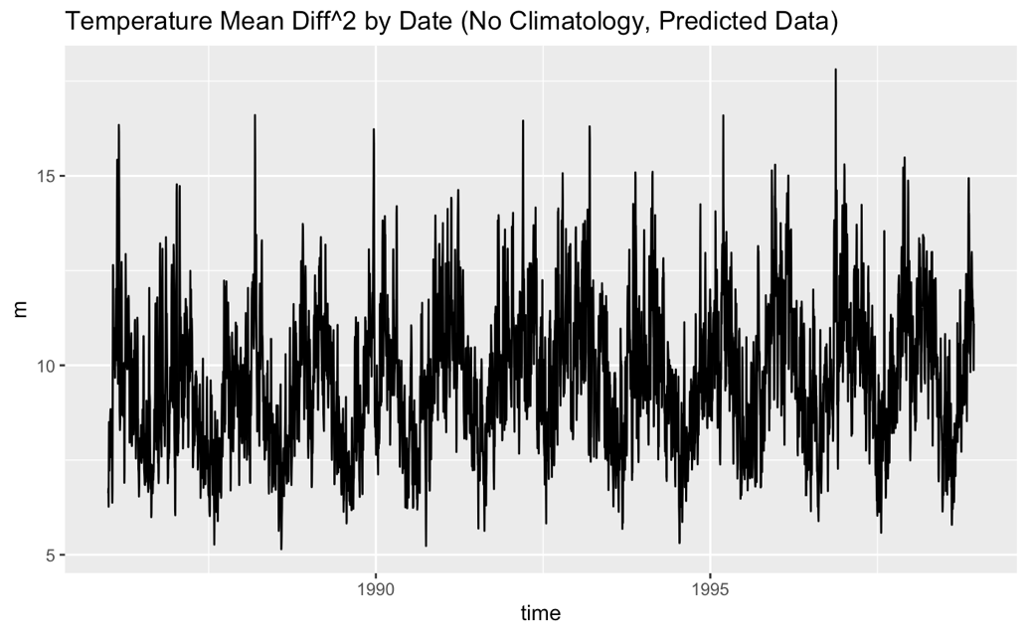 [-0.9961569, 0.8100948]

Range Size:

**1.806252**

Total Mean:

**0.005269719**

In the differences by location, the first three versions differ the most from the actual temp near the poles. This result is interesting because locations near the poles were determined to be some of the most important features in the all of the versions, so the assumption would be that it would predict better near those areas. Clearly, something is not predicting properly near those locations and requires further analysis to ensure a uniform prediction in all locations. Version 4 has concentrated differences near the Chilean Sea specifically, so additional research and manipulation of the process would be required to resolve that issue.

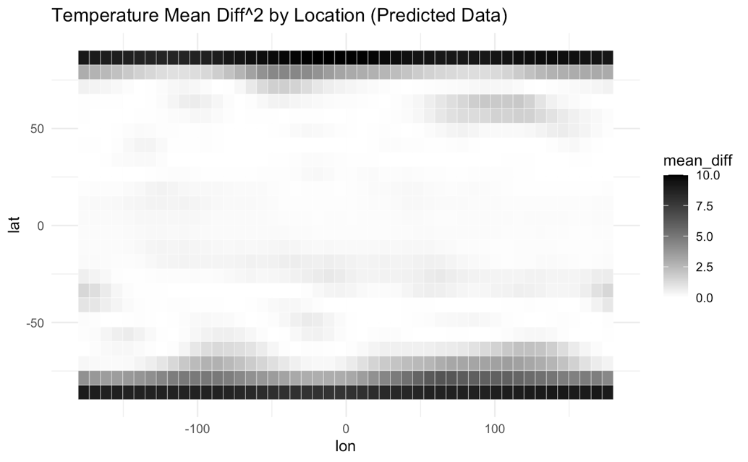

Figure 30

Version 1:

Min/Max:

[-0.2122239, 0.09367101]

Range Size:

**0.3058949**

Total Mean:

-0.03963688

Figure 30

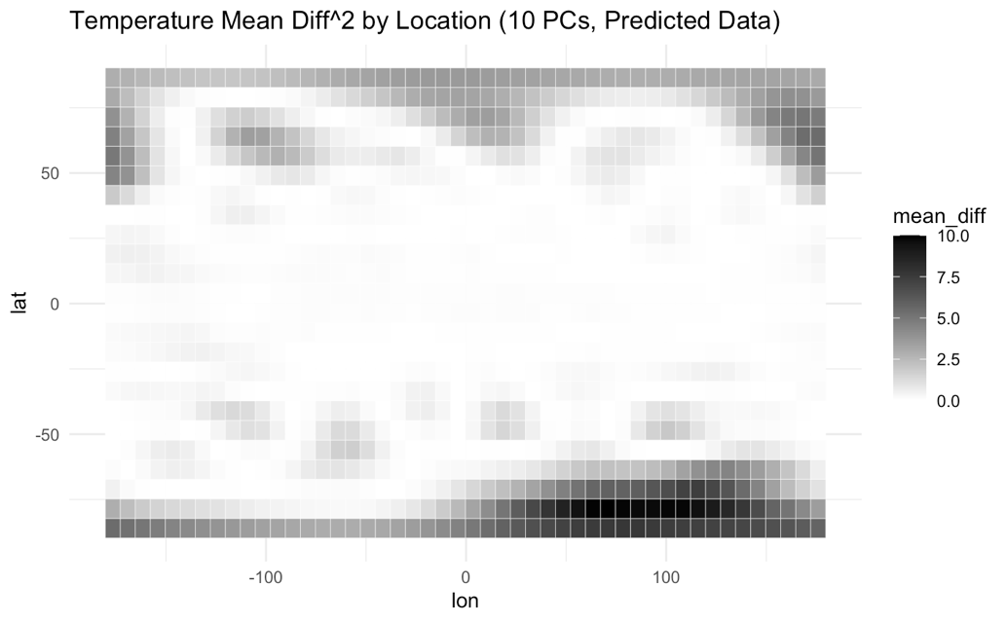Version 2:

Figure 31

Min/Max:

[-0.2372485, 0.1401726]

Range Size:

0.3774211

Total Mean:

-0.02613863

Figure 31

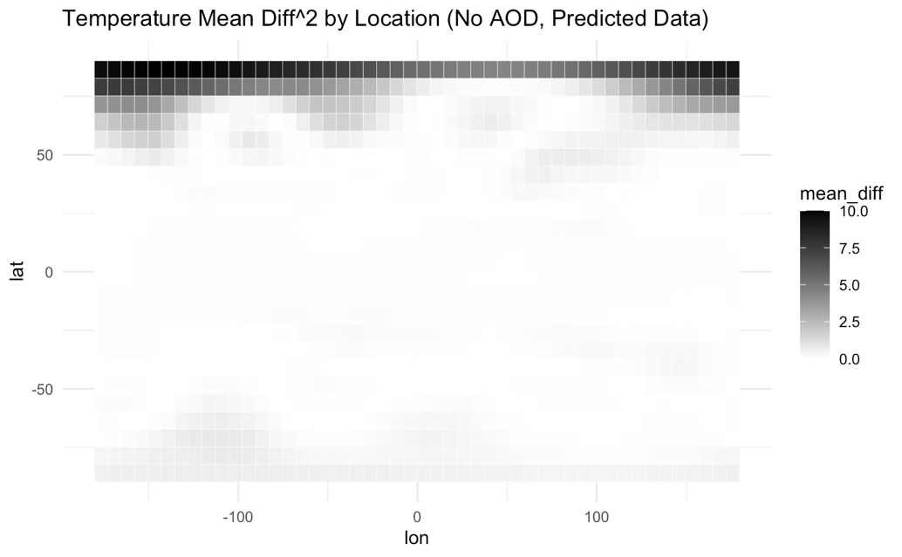

Version 3:

Figure 32

Min/Max:

[-0.2389853, 0.8513257]

Range Size:

1.090311

Total Mean:

0.03487284

Figure 32

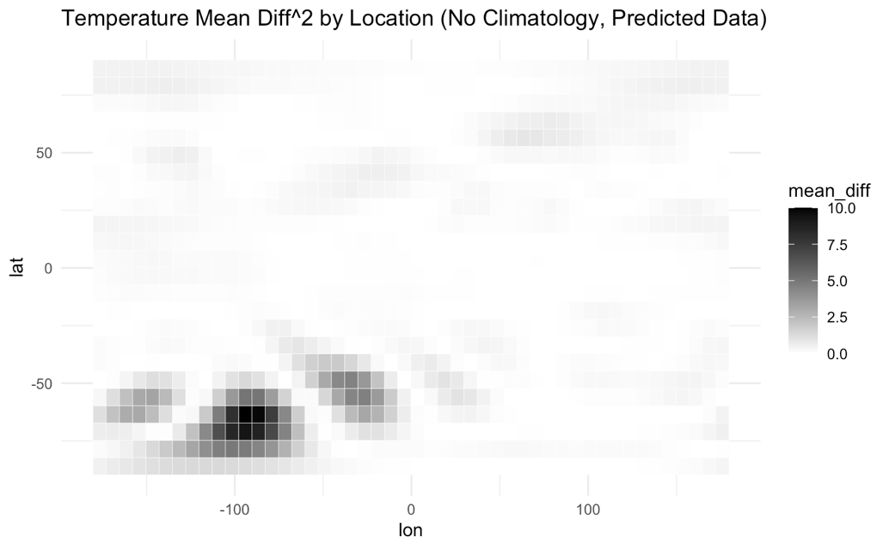

Version 4:

Figure 33

Range:

[-0.2610569, 0.3833888]

Difference:

0.6444457

Mean:

**0.005269719**

Figure 33

**Recomposed & Scaled Temperature Difference (Non-Predicted Values)**

These differences are calculated the same way as the predicted values and are used primarily to see if the data is recomposing incorrectly or predicting incorrectly. The differences over time are all fairly consisten with Version 2 having the least difference. The differences over location are evenly spread with no identifiable areas of concentration, so any stark differences appear to be related to prediction as opposed to PCA, although Version 4 does have the most differences .

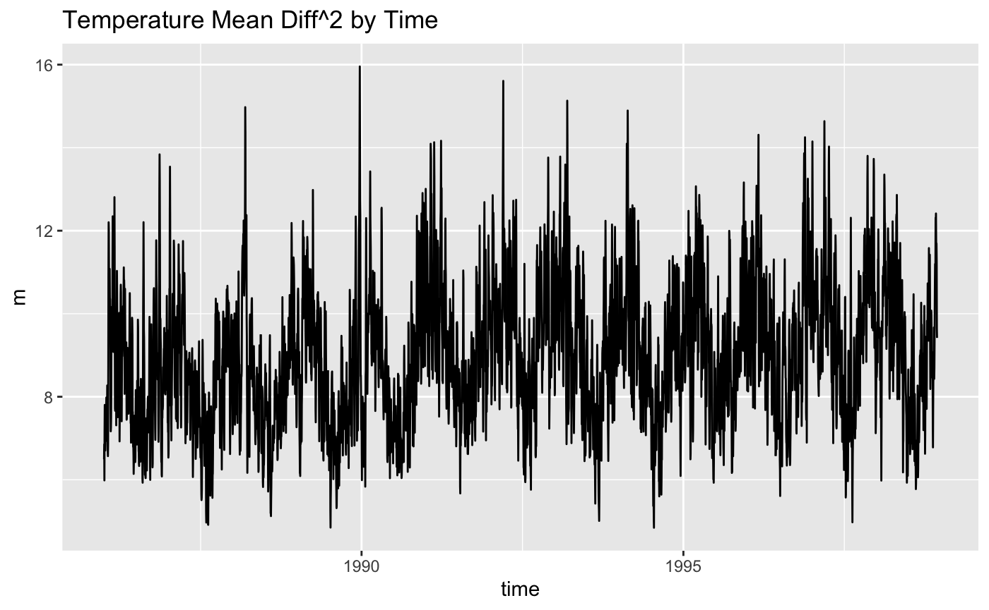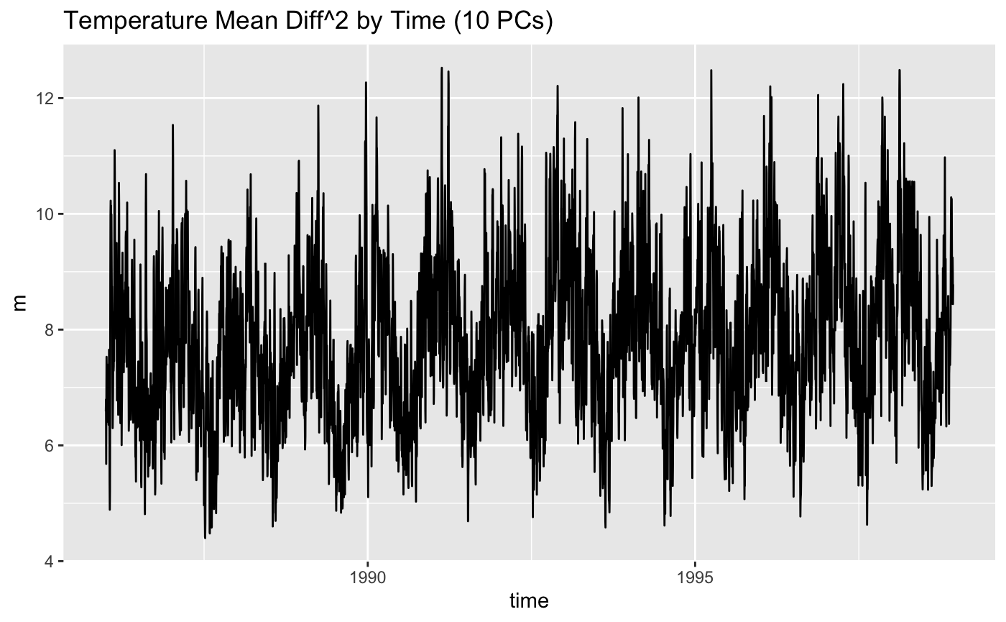

Figure 34: Recomposed Temperature Difference of Non-Predicted Data by Time

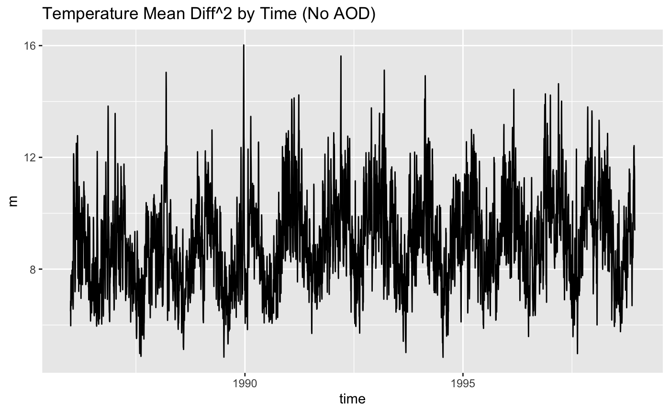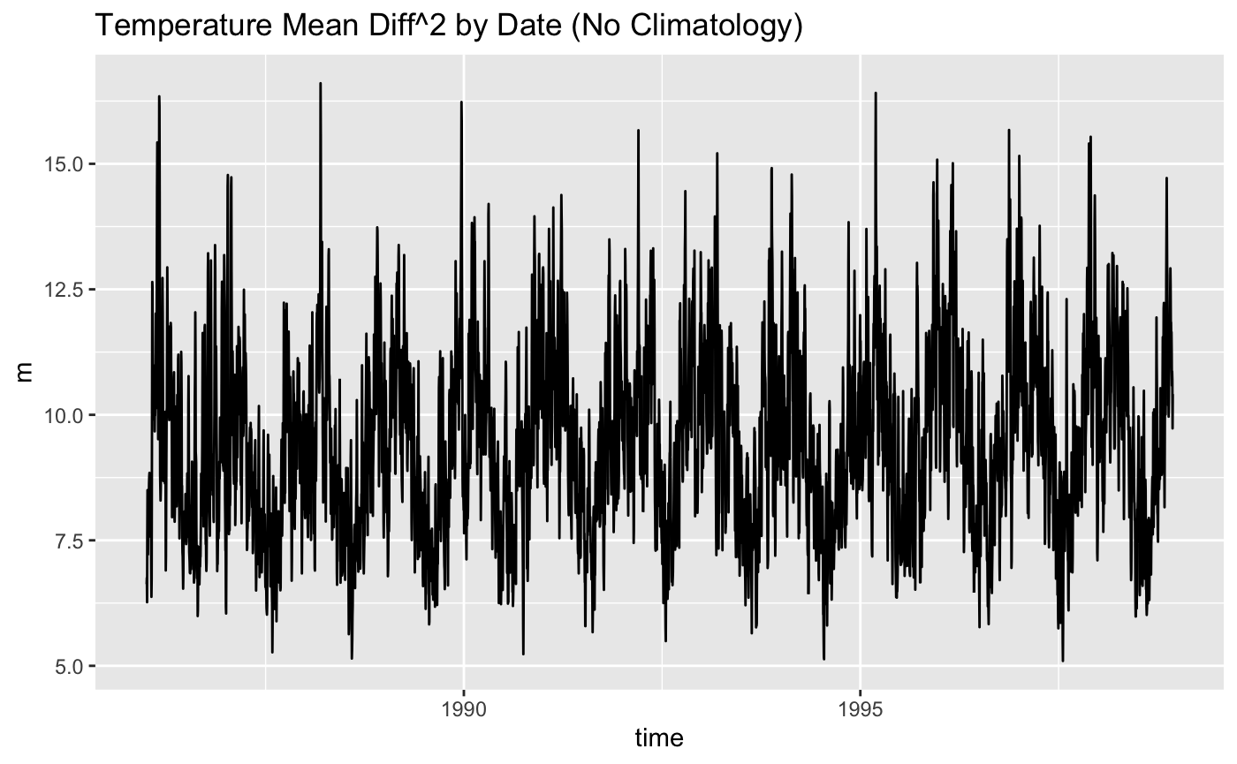

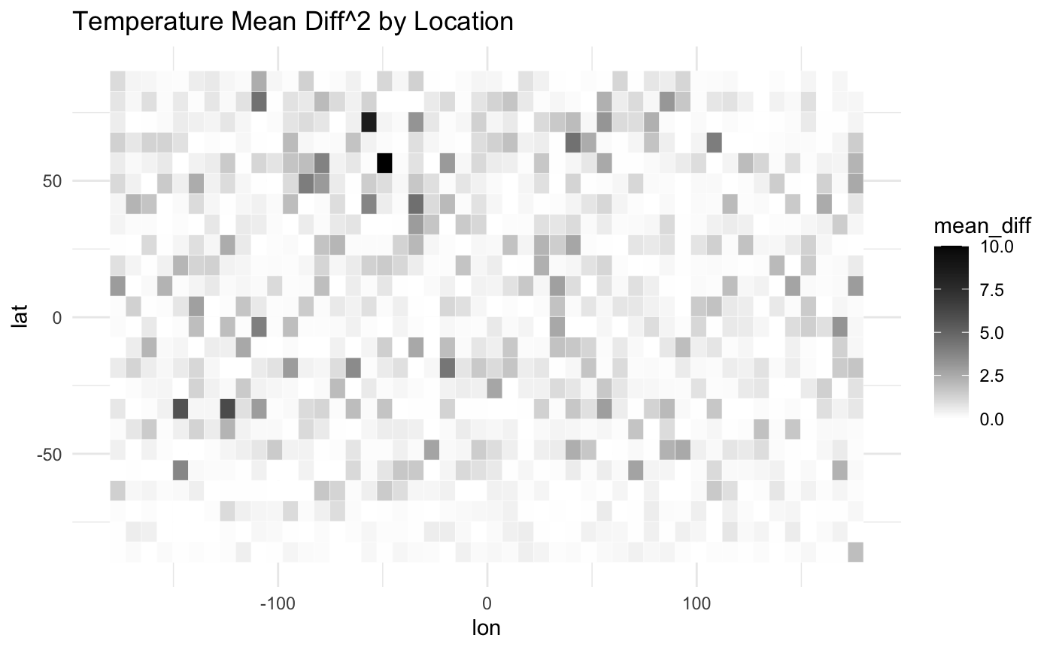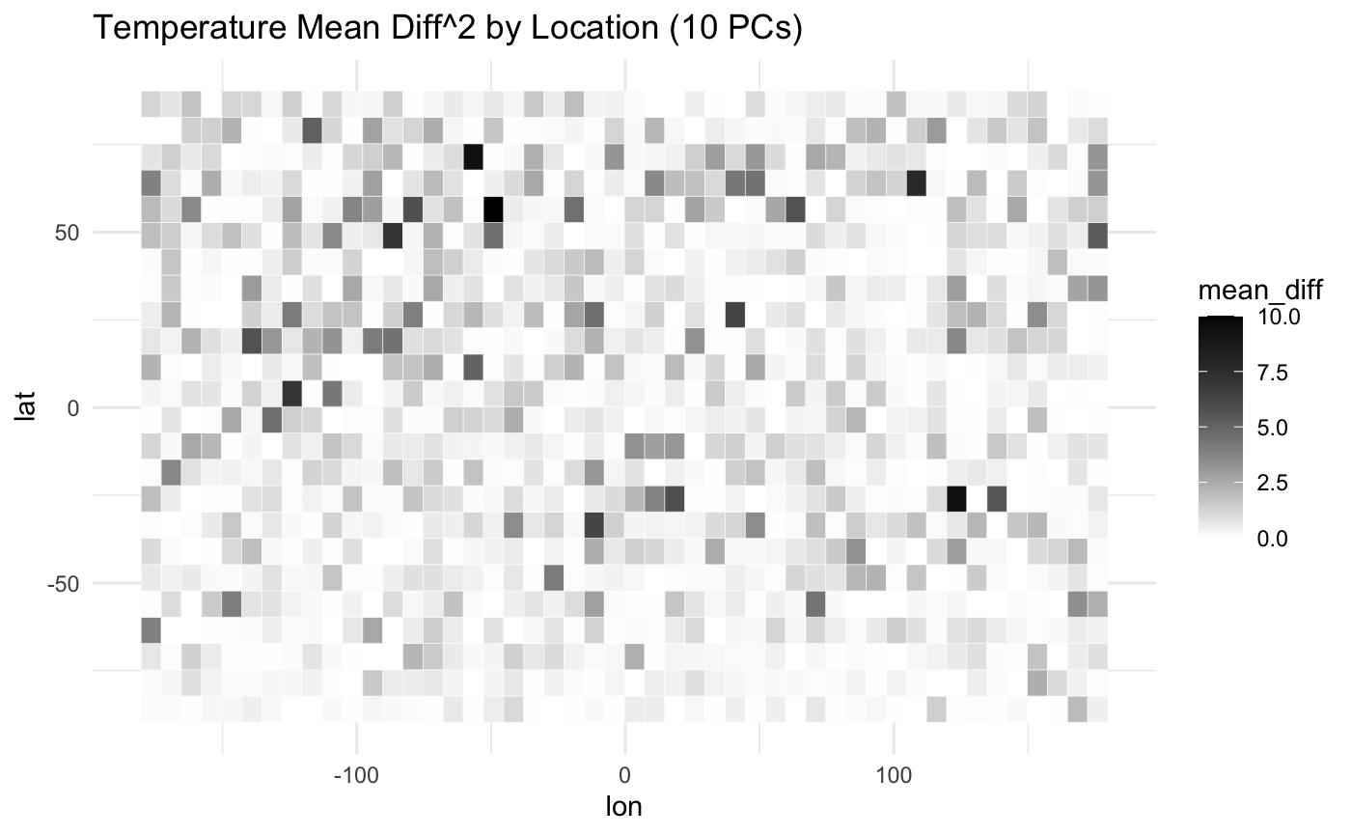

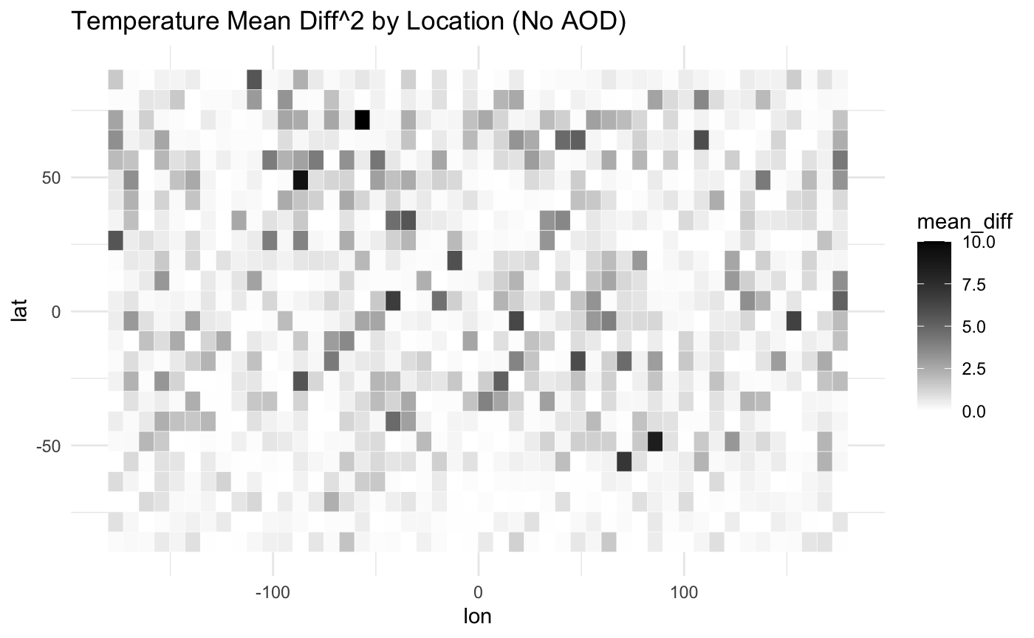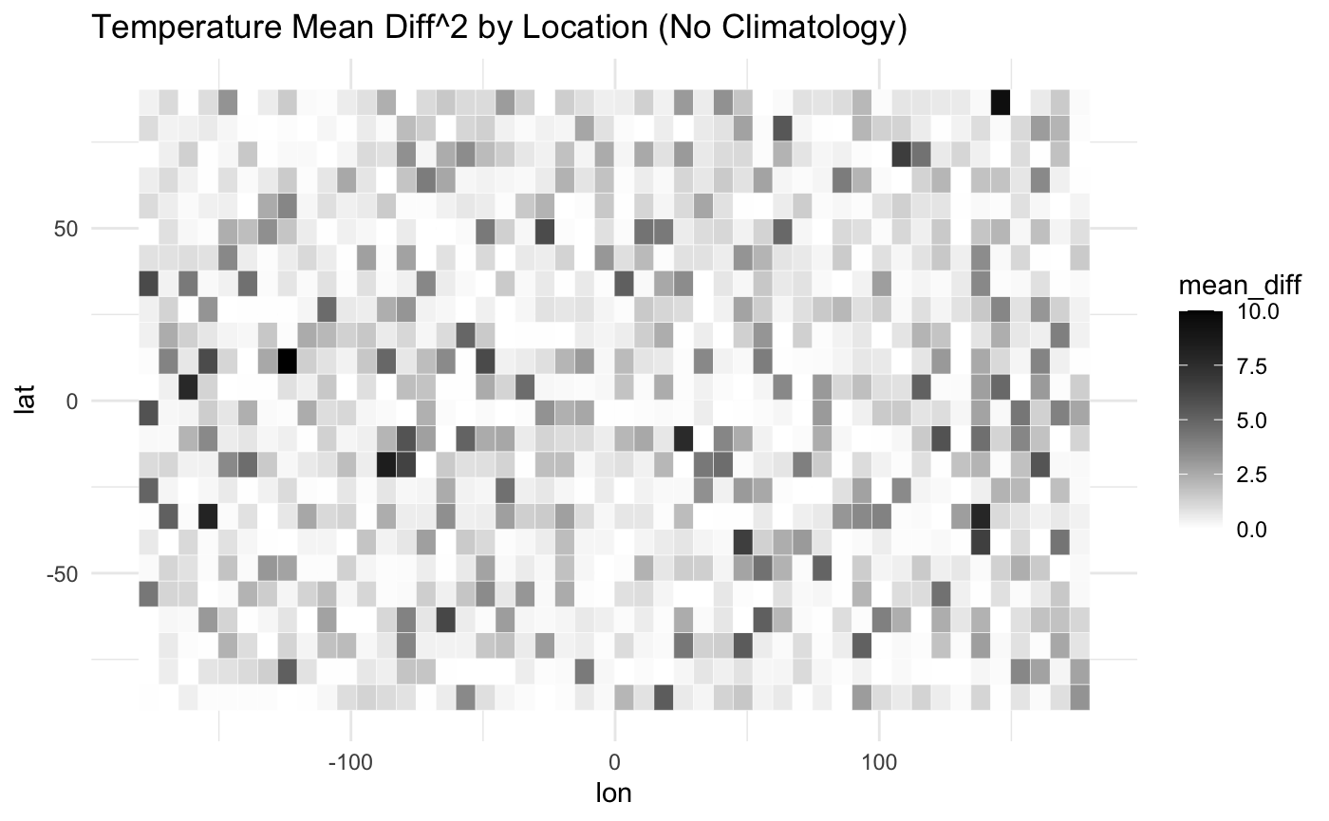

Figure 35: Recomposed Temperature Difference of Non-Predicted Data by Location

**Recomposed AOD Difference**

The differences for AOD all look very similar almost identical when looked at over time (excluding version 3 which does not have AOD) but by location, Version 4 has differences concentrated near Central Africa. When combined with the fact that the predicted data also has a specific area of concentrated differences for that version, it implies that some information necessary for the locations is not being captured.

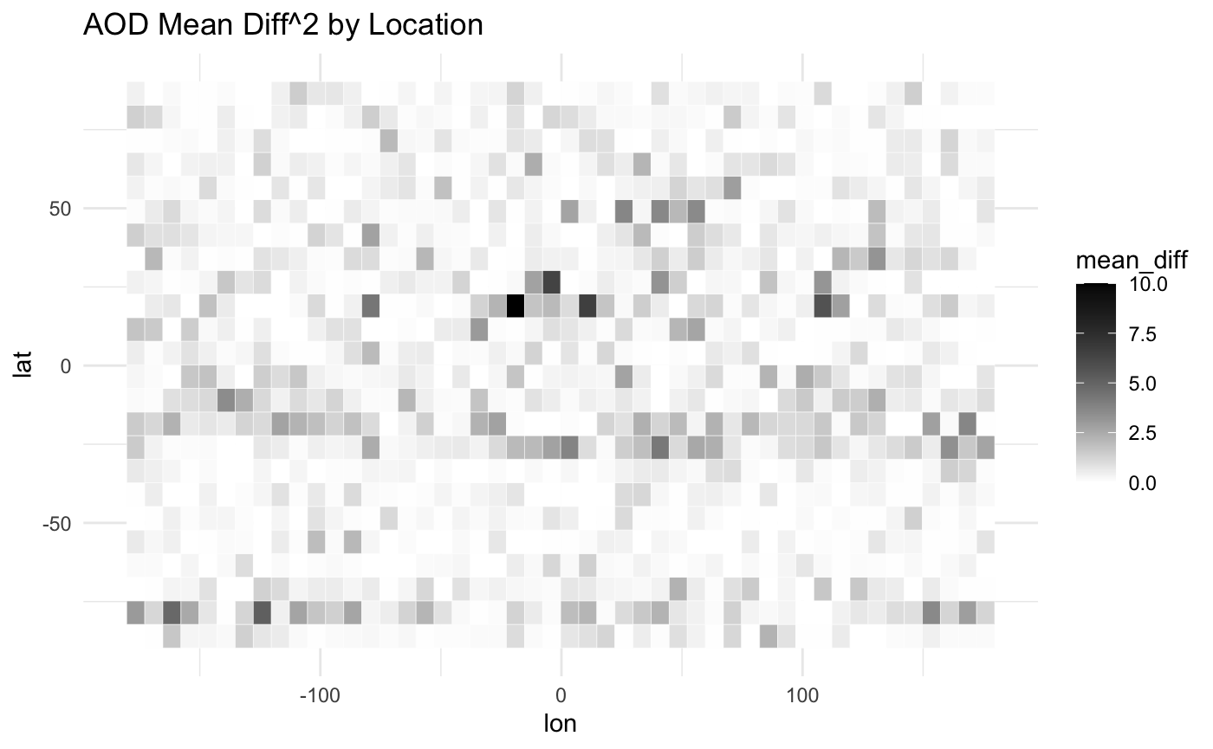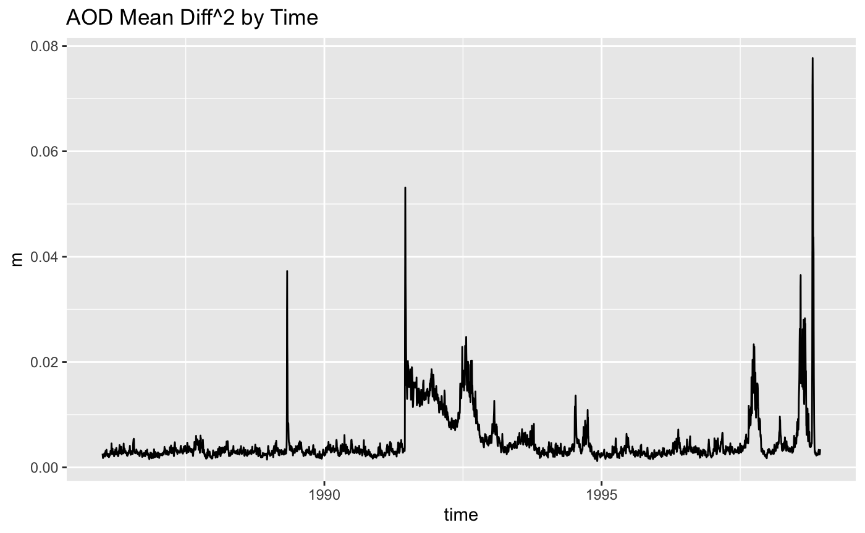

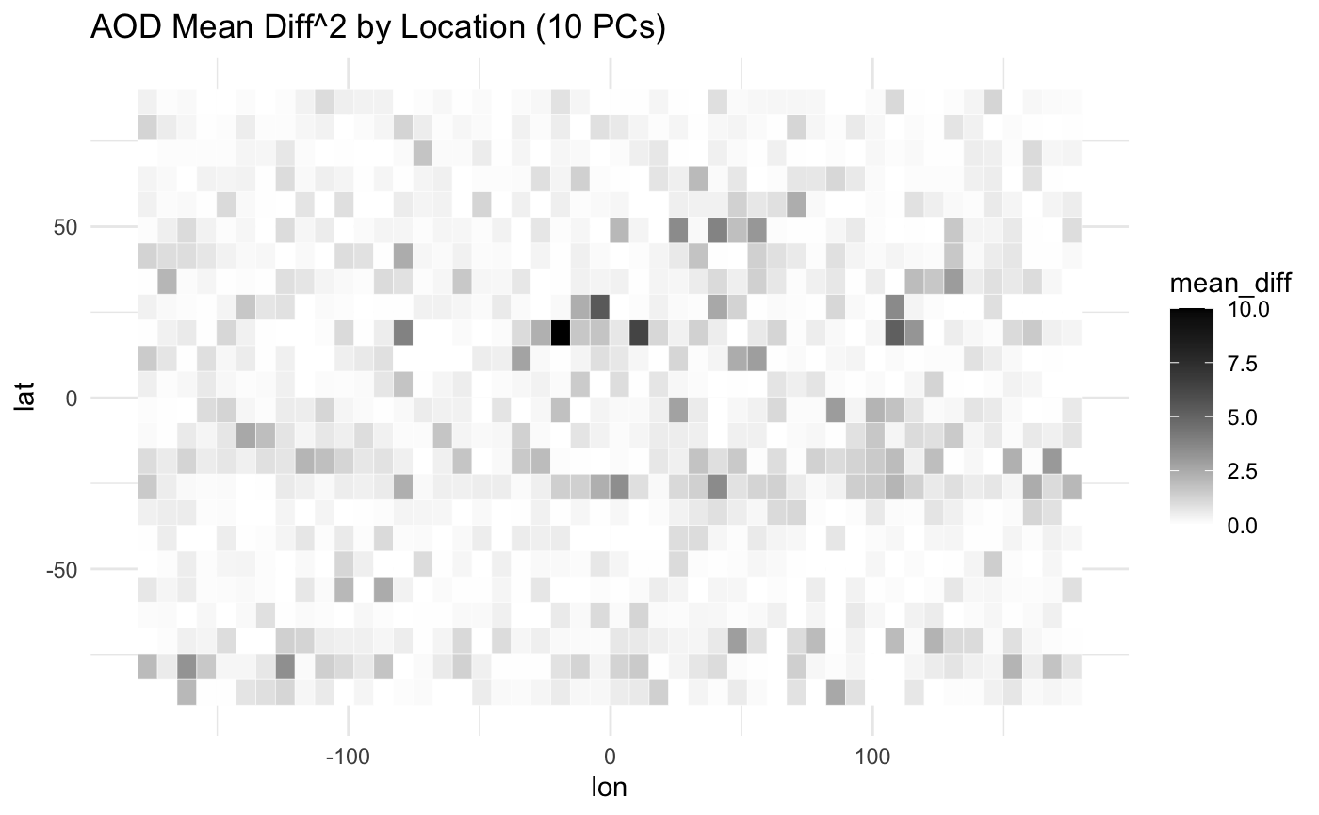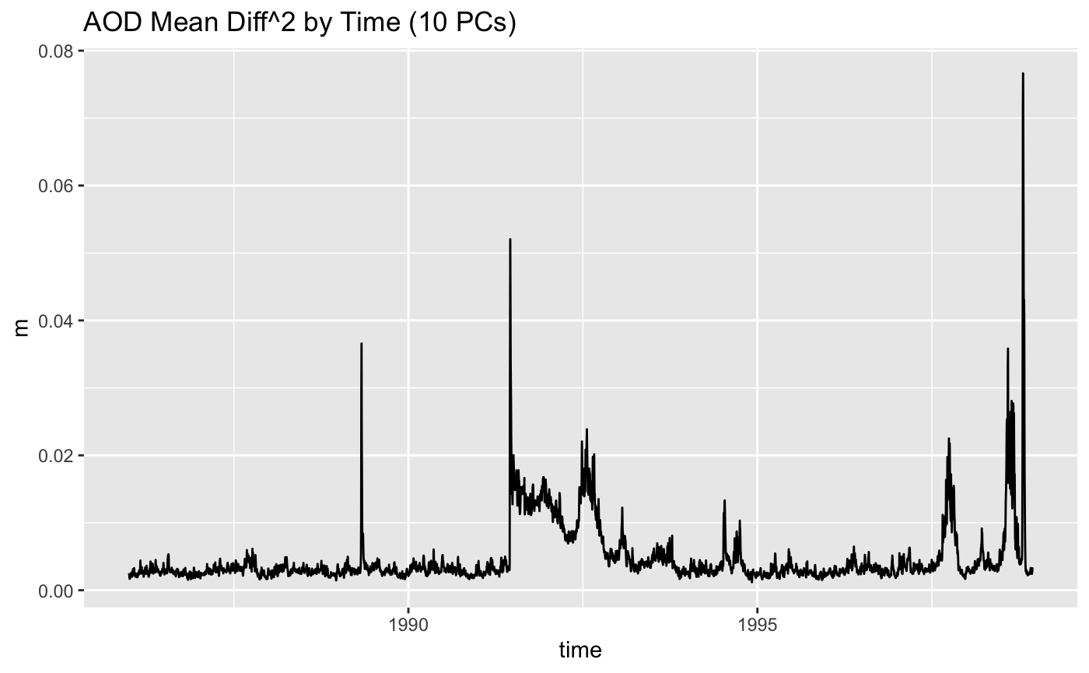

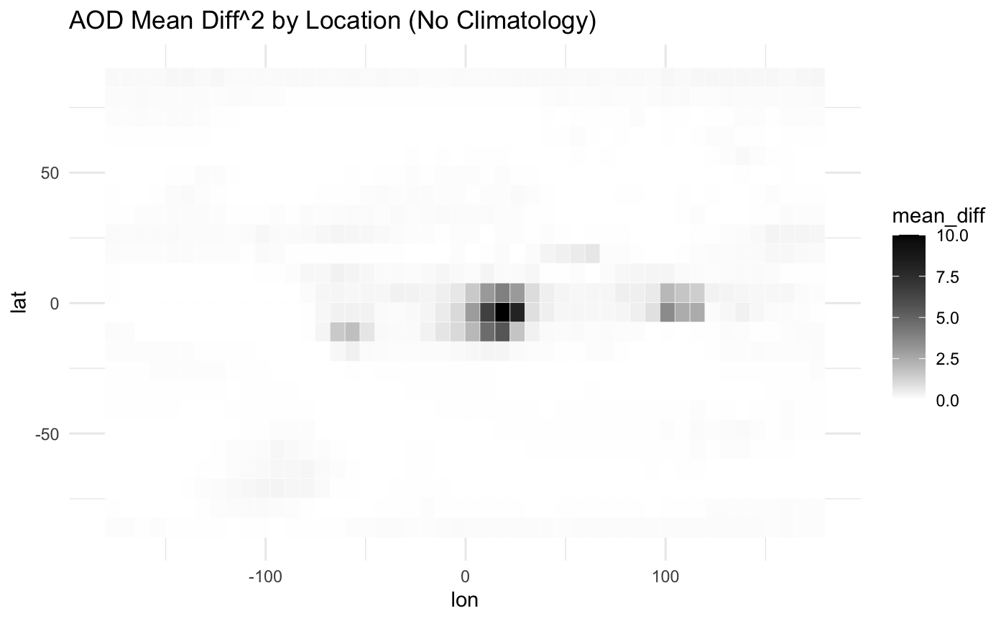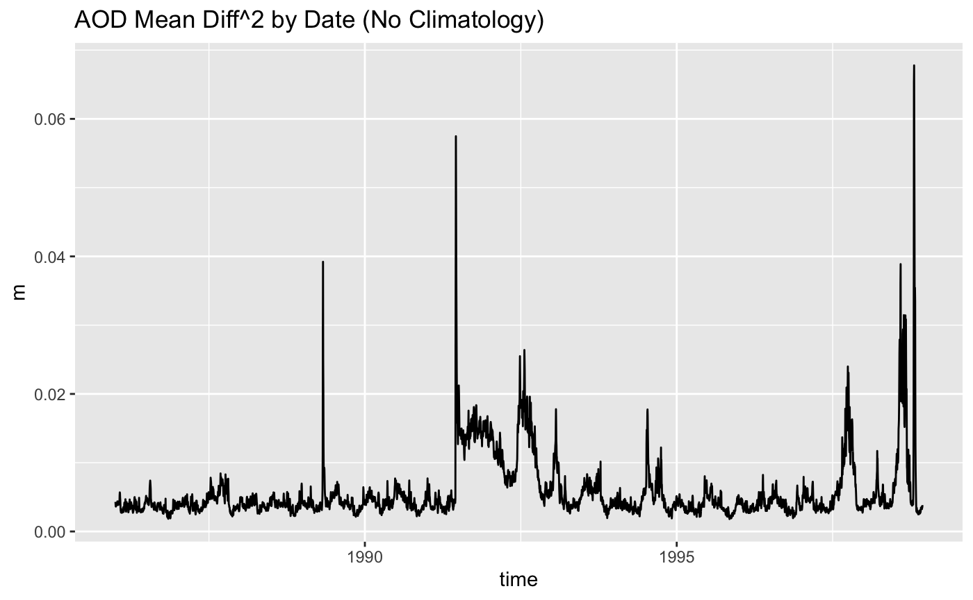

Figure 37: Recomposed AOD Difference by Location (Versions 1, 2. & 4)

Figure 36: Recomposed AOD Difference by Time (Versions 1, 2. & 4)

**Interpretation of Results**

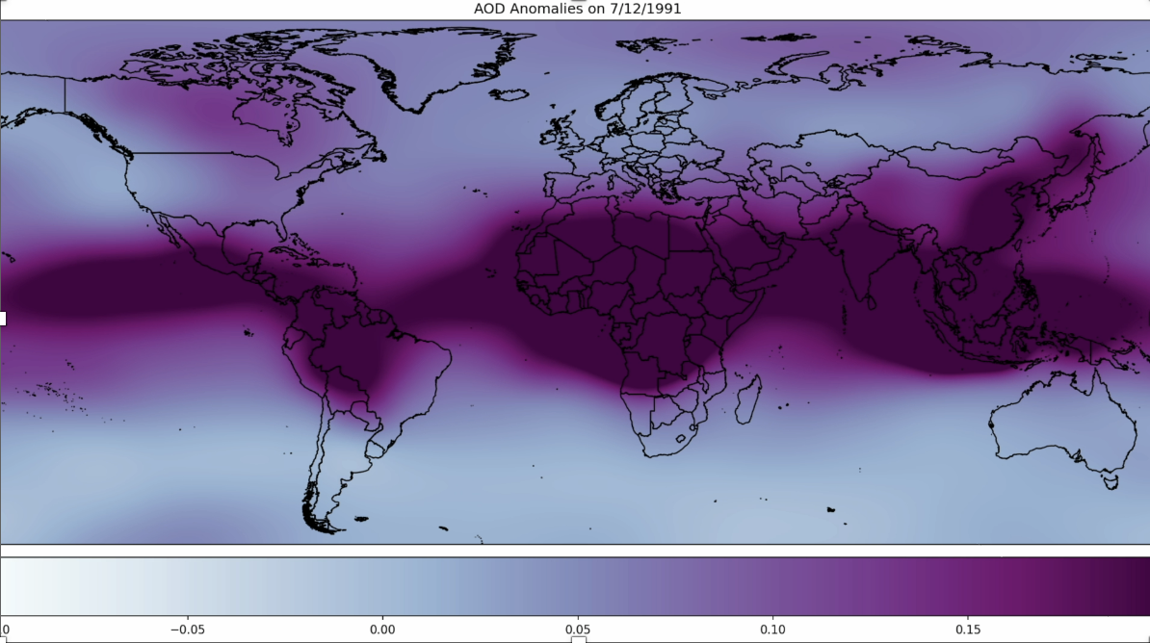In the heat map of AOD and Temperature Anomalies recomposed from Version 1 (Figures 38 & 39) from July 12th, 1991 (approximately one month after the eruption of Mount Pinatubo), there is a clear, although subtle, increase in stratospheric temperature (tinted red on the map) corresponding to the dramatic increased in AOD during that time frame. The increase in stratospheric temperature has a significant correlation with a decrease in surface temperature. The predicted data is fairly diluted compared to the original data, and it seems that the dilution is reflected in the subtle variations on the heat map, which is expected given that the PCA captured less than twenty percent of the variance.

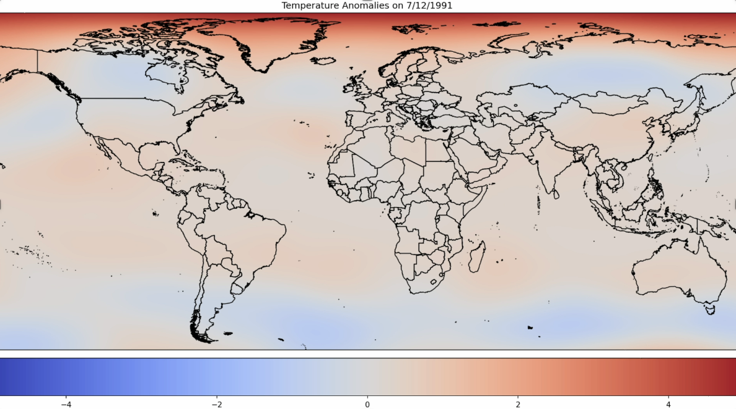

Figures 38 & 39

A heat map of AOD from NASA of the years surrounding Mount Pinatubo’s eruption (Figure 40) shows a more dramatic example of the magnitude of aerosol particulates thrust into the stratosphere.

Figure 40: NASA AOD Heat Map 1991-199417

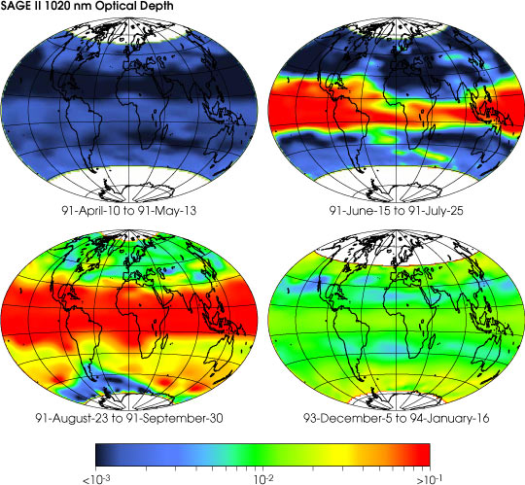

**Conclusion & Next Steps**

It was clear that Version 4 performed better overall with the lowest mean difference, loss, MAE, RMSE, and residuals. This result is likely because that version was able to explain 53.8% of the data variance. In addition, it seems clear that NeuralProphet is meant to be used with seasonal data and when the seasonality is removed to focus on the anomalies, that diminishes the predictive power of the model substantially. While PCA and NeuralProphet did a decent job in predicting the temperatures, there are several ideas that could improve the models but they each have their own challenges.

Increasing the number of Principal Components is an option, although for versions with climatology applied to the data 100+ Principal Components are recommended to encompass approximately eighty percent of the variance. This change would result in a large increase of needed computational power.

For a version without climatology performed, only about twelve Principal Components are needed, but while the non-climatology data had the best predictive results, it falls short in its ability to analyze anomalies.

Utilizing surface temperature as opposed to stratospheric temperature could provide more visible effects, but surface temperature includes many confounding variables making the relationship between the aerosol optical depth and the surface temperature less straightforward.

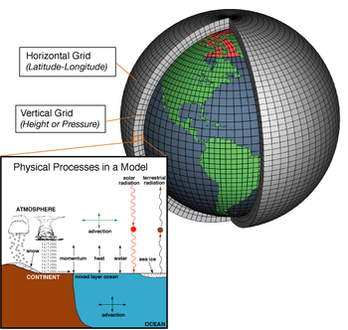

It is possible that the best course of action is to use a model other than NeuralProphet – its real value is in its ability to accommodate seasonality, but that could already be accommodated through climatology. In addition, using models that are meant to work with multiple locations would eliminate the need for dimensionality reduction, thereby increasing accuracy in prediction. Focusing on climate specific models such as Global Circulation Models (GCMs) and Earth System Models (ESMs) would be a possible solution in combination with machine learning.7

Figure 41: Global Circulation Model Visualization7

Figure 42: Four-Phase Hybrid Approach for Solar Forecasts Visualization9

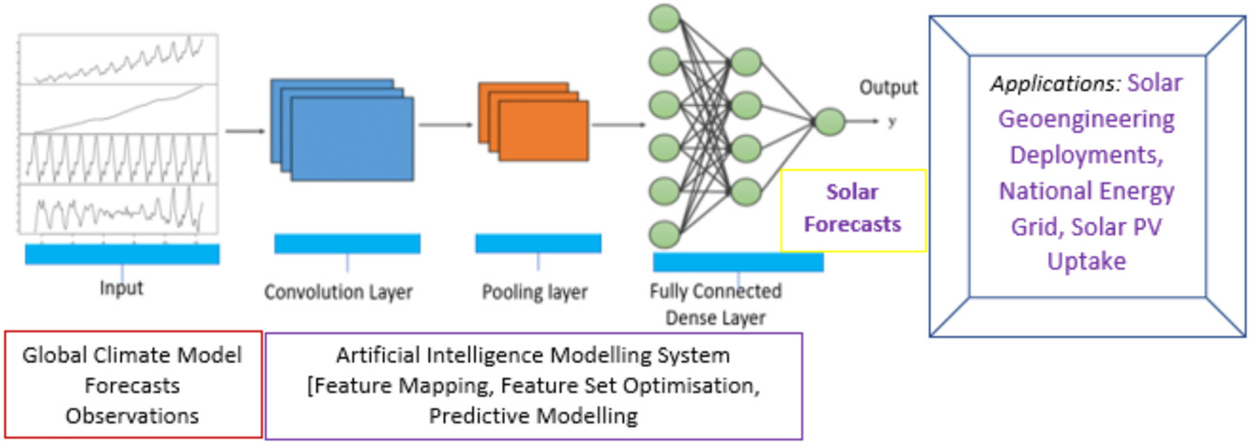In a paper by Ghimire, Sujan, et al., discussing forecasting solar radiation, the authors discussed their hybrid approach with four phases where they use GCMs for initial forecasts and observations, and then utilize Convolution Neural Network, Random Forest Regression, and Harris Hawks Optimization. They compared their model to a Deep Belief Network, Deep Neural Network, Artificial Neural Network, Extreme Learning Machine, and Multivariate Auto-Regressive Spline and found that their four-phase process had better results.9 This approach would likely lend itself well to the research on the impact of stratospheric aerosol injection by combining the relevance of GCMs to spatial data with the predictive capabilities of deep learning and time series.

**References & Works Cited**

1. Campo, Andy Martin del. “Using PCA in a Machine Learning Pipeline.” *Medium*, Medium, 5 Dec. 2019, medium.com/@andymdc31/using-pca-in-a-machine-learning-pipeline-b6fe3492b1b9.
2. Cerliani, Marco. “PCA for Multivariate Time Series: Forecasting Dynamic High-Dimensional Data.” *Medium*, Towards Data Science, 31 Jan. 2023, towardsdatascience.com/pca-for-multivariate-time-series-forecasting-dynamic-high-dimensional-data-ab050a19e8db.
3. “Choosing Colormaps#.” *Choosing Colormaps - Matplotlib 3.8.2 Documentation*, matplotlib.org/stable/users/explain/colors/colormaps.html. Accessed 14 Dec. 2023.
4. *Create a Map*, www.mapcustomizer.com/. Accessed 14 Dec. 2023.
5. Dutt, Aditya. “A Step by Step Implementation of Principal Component Analysis.” *Medium*, Towards Data Science, 18 Oct. 2021, towardsdatascience.com/a-step-by-step-implementation-of-principal-component-analysis-5520cc6cd598.
6. Franko, Lubomir. “Climate Data Visualisation with Python - Visualise Climate Data Using Cartopy and Xarray.” *Medium*, Medium, 10 July 2022, medium.com/@lubomirfranko/climate-data-visualisation-with-python-visualise-climate-data-using-cartopy-and-xarray-cf35a60ca8ee.
7. “General Circulation Model.” *Wikipedia*, Wikimedia Foundation, 4 Dec. 2023, en.wikipedia.org/wiki/General_circulation_model.
8. *Geoengineering Monitor – Stratospheric Aerosol Injection (SAI)*, Nov. 2020, www.geoengineeringmonitor.org/wp-content/uploads/2021/04/stratospheric-aerosol-injection.pdf.
9. Ghimire, Sujan, et al. “Boosting solar radiation predictions with global climate models, observational predictors and hybrid deep-machine learning algorithms.” *Applied Energy*, vol. 316, 19 Apr. 2022, p. 119063, https://doi.org/10.1016/j.apenergy.2022.119063.
10. Hoyne, Caleb & Mukkavilli, s. Karthik & Meger, David. (2019). Deep learning for Aerosol Forecasting.
11. *Interactive Plots Using Hvplot*, tutorial.xarray.dev/intermediate/hvplot.html. Accessed 14 Dec. 2023.
12. Jen, George. “Reconstruct Reverse Principal Component Analysis PCA to Original Raw Dataset.” *Medium*, Medium, 27 May 2023, jentekllc8888.medium.com/reconstruct-reverse-principal-component-analysis-pca-to-original-raw-dataset-f378377e3eff#:~:text=Yes%2C%20you%20can%20reverse%20a,simply%20reverse%20the%20matrix%20multiplication.
13. “Merra-2.” *NASA*, NASA, gmao.gsfc.nasa.gov/reanalysis/MERRA-2/. Accessed 15 Dec. 2023.
14. Oskar Triebe, Hansika Hewamalage, Polina Pilyugina, Nikolay Laptev, and Christoph Bergmeir & Ram Rajagopal. 2021. NeuralProphet: Explainable Forecasting at Scale. (2021). <https://arxiv.org/abs/2111.15397>
15. RainerGewalt. “PCA vs Linear Regression - Therefore You Should Know the Differences.” *Fly Spaceships with Your Mind*, 11 Feb. 2021, starship-knowledge.com/pca-vs-linear-regression.
16. Rosenberg, Matt. “Learn about the 1991 Mount Pinatubo Volcanic Eruption.” *ThoughtCo*, ThoughtCo, 20 Jan. 2019, www.thoughtco.com/mount-pinatubo-eruption-1434951.
17. “Science - Sage (Stratospheric Aerosol and Gas Experiment).” *NASA*, NASA, 26 July 2021, sage.nasa.gov/science/.
18. “Stratospheric Aerosol Injection: A SRM Geoengineering Climate Solution.” *Geoengineering.Global*, 3 Mar. 2023, geoengineering.global/stratospheric-aerosol-injection/.
19. Tolios, Giannis. “Visualizing Climate Change Data with Python.” *Medium*, Towards Data Science, 8 Aug. 2022, towardsdatascience.com/visualizing-climate-change-data-with-python-74ea5bac8756.
20. “What Is Solar Geoengineering.” *Solar Geoengineering Non-Use Agreement*, 9 Feb. 2022, www.solargeoeng.org/what-is-solar-geoengineering/.